Respondus 4.0
User Guide for WebCT 3.x-4.x Personality
rev. March 2010

Getting Started
Computer Requirements
Installation & Setup
Activation Password
Choose a Course Management System (CMS) Personality
On-line Help

Start Menu
Overview
Opening a File
Creating a File
Importing Questions to Respondus
Exam Wizard
Archive Wizard
Changing the CMS Personality and Converting Files

Editing a File
Overview
Common Features Across all Question Types
Question List and Expanded View
- Multiple Choice
- True and False
- Paragraph
- Matching
- Short Answer
- Multiple Response
- Calculated Questions
Adding Bold, Italics, Underline, and Super/Subscript
Media Wizard
HTML Editor
Equation Editor
Power Edit
- Tables
- Fonts, Formatting, and Lists
Spell Check
Keyword Searches

Settings
Overview
Question Sets
Basic Settings
Availability Settings
Security Settings
Submissions Settings
Results Settings
How to Save New Default Settings

Preview & Publish
Overview
Preview
Publish to WebCT
Add WebCT Self-Test
Update Settings
Printing Options

Retrieval and Reports
Overview
Retrieving Reports for Quizzes/Surveys
Downloading Data from Quizzes/Surveys
Retrieving a Quiz or Category from WebCT

Other Tools & Features
Overview
Save As Copy
Save As StudyMate Class Format
Preferences
Question Title Tool
Check for Update

Disclaimer of Warranty

Copyright, Ownership, and Use of Software

Getting Started
Computer Requirements
Installation & Setup
Activation Password
Choose a Course Management System (CMS) Personality
On-line Help

Respondus is a powerful tool for creating and managing exams that can be printed to paper or published directly to Blackboard, eCollege, WebCT and other eLearning systems. Exams can be created offline using a familiar Windows environment, or moved from one eLearning system to another.

Computer Requirements
Respondus requires Windows 98 or higher, 32 MB of RAM, 6 MB of free hard disk space, and a 800x600 monitor (1024x768 recommended). Respondus is generally used in conjunction with a course management system such as ANGEL, Blackboard, Desire2Learn, eCollege, WebCT, and can also be used with IMS QTI-compliant assessment systems.

Installation and Setup
The Respondus installation program can be downloaded from www.respondus.com. To begin the installation process, locate the Respondus4.exe file that was downloaded to your hard drive. Double-click the file to start the Respondus installation program and follow the instructions on the screen. Once Respondus is installed, start the program by double-clicking the Respondus icon that appears on the Windows desktop. Or, follow these steps to start the software.

Click [Start] from the Windows desktop
Click [Programs]
Click [Respondus]
Click [Respondus X.x]

The first time you start Respondus (and each time thereafter until the program is registered), you will be presented with a screen that provides the “Product ID#”. The Product ID# is used to obtain the Activation Password (see below) which is needed to complete the installation.

Activation Password
Once the Respondus installation program is finished, you will need to obtain a password from www.respondus.com to activate the installation. Be sure to have the “Product ID#” (see previous paragraph) readily available. After you have directed your browser to www.respondus.com, go to the “Registration” section of the site. You have the choice of purchasing a permanent activation password or obtaining a 30-day trial password. In both cases you will be required to enter a valid e-mail address and the Product ID# that displays on the opening screen of Respondus. Once the information is submitted, the activation password is immediately sent to the e-mail address you specified.

Once the password is received by e-mail, it must be entered into the Respondus program. If you haven’t done so already, start Respondus and then enter the password when prompted (you may want to “copy and paste” the password from the e-mail message in order to prevent typing mistakes). Click [OK] to continue. The Respondus software is now activated, either permanently or for a 30-day trial period.

Choose a Course Management System (CMS) Personality
Immediately after the Respondus software is activated, you are prompted to select a Course Management System (CMS) “personality.” Respondus offers various user environments (called personalities) that parallel the features and terminology used by specific course management systems, such as Blackboard, eCollege and WebCT. You can change the “personality” at any time in Respondus from the Start menu.

On-line Help
Respondus includes a full-featured help system that includes an index and context-sensitive help. To view the on-line help, choose “Help Topics” from the pull-down Help menu and select a topic. You can also press the F1 key from within Respondus to obtain context-sensitive help. Throughout the program you will additionally see small buttons having a “?” symbol. When the button is clicked, information on that particular option or task is provided.

If you encounter a question that is not answered in the on-line help or in this manual, you are encouraged to visit the “Support” section of our web site (www.respondus.com). There you will find Frequently Asked Questions (FAQ) and other resources.

The remainder of this user manual is organized according to the five menus used in the “WebCT Personality” of Respondus: Start, Edit, Settings, Preview & Publish, and Retrieval & Reports.

Start Menu (WebCT Personality)
Overview of Start Menu
Opening a File
Creating a File
Importing Questions to Respondus
Exam Wizard
Archive Wizard
Changing the CMS Personality and Converting Files

Overview of Start Menu
The Start menu provides the ability to Open a Respondus file, Create a new file, and Import questions from a text file. The Exam Wizard provides the easiest way to create an exam from an existing set of questions. The Archive Wizard allows you to archive an exam or survey, including all media components and equations, with a single click.

A Respondus file must be open before you can go to another menu in Respondus.

Opening a File
From the Start menu, click the Open button. The following window will appear:

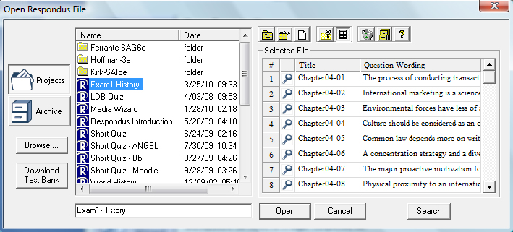

Highlight an exam or survey “project” by clicking it once. To obtain information on the project, select one of the two center buttons located to the top right of the project list. Select the “Item List” button (right of center) to view a list of the questions that are available in the highlighted project. To preview a particular question, click the “Title” of the question.

To open a highlighted project, click the [Open] button at the bottom of the window. (Double-clicking a file name will also open it.)

Respondus allows projects to be organized within folders. For example, you can place the exams for a particular course within a folder rather than having exams for all courses listed together. To create a new folder, click the “Create New Folder” button located second from left. To navigate down a level within a folder, double-click on the folder itself. To navigate up a level, click the “Up One Level” button located leftmost on the row of buttons.

The [Browse…] button, located on the lower left side of the window, allows you to locate a Respondus file (.rsp) located elsewhere on your hard drive and copy the file to the Respondus Projects folder. It does not move the file or open it directly, rather, it creates a new “Projects” folder based on that file. The [Browse…] button can also be used to locate a Respondus “archive” file (.rsa or .rpa) and to restore it to the Projects directory (see Restoring an Archive File).

The [Search] button allows a file to be searched prior to opening it (it can only be used if the “Item List” view is selected). Searching is particularly useful if you are trying to locate a particular question or set of questions in a file.

The [Download Test Bank] button is used to download test banks that are distributed by textbook publishers. Hundreds of the leading textbooks for higher education have test banks available in Respondus format. These can be downloaded via the Internet with the Respondus software. (For complete details, see the “Respondus Test Bank Network” at www.respondus.com.) To download a test bank, enter the File Code and password that is supplied by the publisher. Respondus will automatically locate, download, and restore the test bank file and place it in the Respondus Projects folder.

Once a file is opened, the screen automatically changes to the Edit menu.

Creating a File
From the Start menu, select the Create button to create a new file. You are first prompted to enter a file name and a description for the file. Then you must indicate whether the file is an “Exam” or a “Survey.” An exam file can be used to create a WebCT quiz or a self-test. The type of file you create (or open) will determine the features that are available throughout the program. Click [OK] when you are finished. Once a file is created, you are automatically switched to the Edit menu. This is where you add questions to the file.

Importing Questions
Respondus allows you to import multiple choice, true-false, paragraph, short answer, matching, and multiple response questions from a file. The questions must be organized in a format that is acceptable to Respondus and the file must be stored in one of the following formats: plain text (.txt), rich-text (.rtf), or Microsoft Word (.doc and .docx) or tab/comma delimited (.csv) format. (All word processors have the capability of saving files to .txt or .rtf format)

Note: Importing questions from the Microsoft Word .docx format requires that Word 2007 or Word 2010 be installed on the same computer. The docx format has better support for importing text with formatting like auto-numbers and auto-letters.

The formatting required for all file formats except for .csv files is described in the section entitled “The Standard Format for Importing Documents.” The formatting required for .csv files is described in the section “Importing Tab/Comma Delimited Files (CSV)”. Once the file is in the Standard Format, follow these steps to import it into Respondus.

Starting the Import
From the Start menu, select the [Import Questions] task. The following dialog will appear:
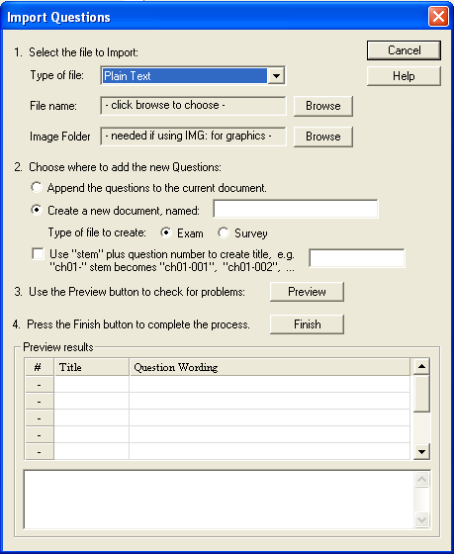

Step 1
The first step is to select the type of file that will be imported. The “Standard Format” for organizing questions is the same for Plain Text (.txt), Rich Text (.rtf) files, and Microsoft Word (.doc and .docx) files. Files that are in rich text (.rtf) and MS Word (.doc and .docx) format will retain some of the enhanced question formatting such as bold, italic, underline, superscript, and subscript. Embedded graphics can only be imported if the file is in Microsoft Word (.doc or .docx) format, although an alternative method is available for .rtf and .txt files (see Importing Images below). Note that certain types of enhanced importing cannot be imported. If the enhanced formatting causes a problem with an import, consider saving the file to rich text or plain text format and then try the import again.

Next, use the [Browse] button to locate and select the file to be imported.

Images embedded in MS Word files will import automatically. However, if images are being imported with csv, rich-text, or txt files (see Importing Images below), browse to the folder that contains those images.

Step 2
Specify whether the questions should be added to the currently open file or whether to create an entirely new file. If you select the second option you will need to enter the name of the file to be created and indicate whether the file should be an “Exam” or “Survey.”

Each question being imported will have a “title”. If you don’t specify a title for each question in the text file itself (discussed below), Respondus will automatically use the first 20 characters of the question wording as the question title. Alternatively, titles can be based on a specific “stem” (or string of text) which will then be followed by consecutive numbering starting with 001. For example, if you select the “Use stem...” checkbox and enter the text “Chapter1-,” the title for the first question being imported will be Chapter1-001, the title for the second question will be Chapter1-002, and so on. (You do not have to enter a stem phrase--this feature is entirely optional.)

Step 3
Click the [Preview] button to preview the file being imported and to see if there are any warning messages. If warning messages are shown at the bottom of the screen, you need to determine whether to make changes to the text file or whether to continue with the import. Be aware that some warning messages don’t actually require you to make a change to the file being imported. For instance, Respondus will generate a warning message if two questions being imported have the same title (Respondus will place the number “2” at the end of the second title to make it distinct from the first). But if you don’t care about this issue, you can ignore the warning message.

Step 4
If you are satisfied with how the results look in Preview, click [Finish] to complete the import. The Respondus file has now been created or appended. Switch to the Edit menu to modify the file, or go to the Preview menu to view the file using a browser-like window.

The Standard Format for Importing
Respondus will import multiple choice, true-false, paragraph, short answer, matching, and multiple response questions. The plain text, rich-text, or MS Word file must be organized in the “Standard Format” before it can be imported into Respondus. The Standard Format for multiple choice questions has required elements and optional elements, each of which is described below. This is followed by an explanation of the formatting required for true-false, paragraph, short answer, matching and multiple response questions.

Required Elements (Multiple Choice)
Each question must begin with a question number, followed by either a period “.” or a parentheses “)”.

Example: 3)
Example: 3.

The question wording must follow the question number. (Note: at least one space should be between the question number and the question wording.)

Example: 3) Who determined the exact speed of light?
Example: 3. Who determined the exact speed of light?

Each answer must begin with a letter (A-Z) followed by a period “.” or a parentheses “)”.

Example: 3) Who determined the exact speed of light?

a. Albert Einstein
b. Albert Michelson
c. Thomas Edison
d. Guglielmo Marconi

Optional Elements (Multiple Choice)

A Title can be imported with each question. If a title is not provided for a question, the first 20 characters from the question wording will be used as the question title. Titles must be placed at the beginning of a question and begin with “Title:” followed by the actual text for the title. If the title exceeds 20 characters, the remaining characters will be dropped during the import.

Example: Title: Speed of Light
3) Who determined the exact speed of light?

a. Albert Einstein
b. Albert Michelson
c. Thomas Edison
d. Guglielmo Marconi

For imports into an Exam file, correct answers can be indicated in two ways. First, you may place an asterisk (*) directly in front of the answer choice (do not put a space between the asterisk and the answer choice).

Example: Title: Speed of Light
3) Who determined the exact speed of light?

a. Albert Einstein
*b) Albert Michelson
c) Thomas Edison
d. Guglielmo Marconi

The second option is to place a list of correct answers at the end of the file. The list must begin with the word “Answers:” and must be positioned at the end of the file. (Note: Any text after the answer list will be ignored.)

Example: Answers:
1. A
2. C
3. B

If neither method is used to select a correct answer, Respondus will automatically select the letter “A” as the correct answer. Don’t worry, you will be warned if a question does not have an answer selected for it prior to completing the import. (Note that survey files should not have “correct answers” selected. If you are importing questions into a survey file, any correct answer designations will be ignored.)

With an Exam file, feedback for individual answer choices can be imported by placing the feedback immediately after the answer choice and by beginning the line with the @ symbol. There must be at least one space between the @ symbol and the feedback text.

Example: Title: Speed of Light
3) Who determined the exact speed of light?

a. Albert Einstein
@ No. Albert Michelson determined the exact speed of light.

*b) Albert Michelson
@ Yes. Albert Michelson won the Nobel Prize for Physics for determining the exact speed of light.

c) Thomas Edison
@ No, Thomas Edison did not determine the exact speed of light.

d. Guglielmo Marconi
@ No. Marconi did not discover the exact speed of light, but he did win the Nobel Prize for Physics for his work with radio waves.

“General Feedback” can be imported in a similar way, but it must appear immediately after the question wording and before any of the answer choices. The line must also begin with the @ symbol, and there must be at least one space between the @ symbol and the feedback text.

Example: Title: Speed of Light
3) Who determined the exact speed of light?
@ Albert Michelson was the first American to win the Nobel Prize in Physics (1907) for his measurements of the speed of light. His experiments laid the groundwork for Einstein’s Theory of Relativity.

a. Albert Einstein
@ No. Albert Michelson determined the exact speed of light.

*b) Albert Michelson
@ Yes. Albert Michelson won the Nobel Prize for Physics for determining the exact speed of light.

etc.

As shown in the previous example, both types of feedback can be used within a single question. (Note: if you are importing questions into a survey file, all feedback designations will be ignored.)

Importing True and False Questions
The process of importing a “true and false” question is similar to that used for importing multiple choice questions (see above). Both of the following examples are valid ways to format a true and false question for importing purposes.

Example: 3) Albert Michelson determined the exact speed of light?

*a) True
b) False

Example: 3) Albert Michelson determined the exact speed of light?

*a. T
b. F

It’s important to note that the “True” (or “T”) answer choice must be listed prior to the “False” (or “F”) answer choice in order for Respondus to recognize it as a true and false question type. (If “False” appears first in the list, the question will be imported as a “multiple choice” question).

To include a “title” or “feedback” with the true and false question, follow the same formatting rules described above for multiple choice questions. For instance,

Example: Title: Light speed
3) Albert Michelson determined the exact speed of light?
@ Correct. Albert Michelson won the Nobel Prize for Physics for determining the exact speed of light.

*a. True
@ Yes. Albert Michelson won the Nobel Prize for Physics for determining the exact speed of light.

b. False
@ The correct answer is True. Albert Michelson determined the exact speed of light and won the 1907 Nobel Prize for Physics for his efforts.

A second way to designate a correct answer for a true and false question is to place it in a list of correct answers at the end of the file. The list must begin with the word “Answers:” and must be positioned at the end of the file. (Note: Any text after the answer list will be ignored.) The correct answer for a true and false question can be designated in three ways: (1) using the complete words “True” and “False,” (2) using the letters “T” and “F,” or (3) using the alphabetical letters “A” (for true) or “B” (for false). For example, the formatting of each of the following answers is acceptable for true and false questions in which all of the answers are “true”:

Example: Answers:
1. True
2. T
3. A

Importing Paragraph Questions
The logic for importing paragraph questions (also known as “essay” or “open-ended” questions) is similar to what is described above for multiple choice questions. The primary difference is that the first line of formatting must begin with “Type: P”. This is followed by the “Title” (which is optional), the question number, and the question wording.

Example: Type: P
Title: Michelson-Morely experiment

4) How is the Michelson-Morely experiment related to Albert Einstein’s theory of relativity?

If you are importing a paragraph question into an Exam file, you can supply an answer two different ways. First, you may provide an answer immediately after the question wording, in which the answer begins with “a.” or “a)” (without the quotes).

Example: Type: P
Title: Michelson-Morely experiment

4) How is the Michelson-Morely experiment related to Albert Einstein’s theory of relativity?

a) In 1887, Albert Michelson and Edward Morely carried out experiments to detect the change in speed of light due to ether wind when the Earth moved around the sun. The result was negative. They found the speed of light is always the same regardless of Earth's motion around the sun. Scientists were puzzled with this negative result, and they didn't know how to explain it. Albert Einstein came up with the answer in his famous second postulate in theory of relativity: that the speed of light (in vacuum) is always constant and absolute, regardless of its source's motion and observer's movement.

The second way to supply an answer for a paragraph question is to place it in a list of correct answers at the end of the file. As described above with multiple choice questions, the list must begin with the heading “Answers:” and must be positioned at the end of the file. A paragraph answer should begin with the corresponding question number, followed by either a period “.” or a parentheses “)”. This is then followed by a space and then the answer.

Example: Answers:
1. A
2. C
3. B
4. In 1887, Albert Michelson and Edward Morely carried out experiments to detect the change in speed of light due to ether wind when the Earth moved around the sun. The result was negative. They found the speed of light is always the same regardless of Earth's motion around the sun. Scientists were puzzled with this negative result, and they didn't know how to explain it. Albert Einstein came up with the answer in his famous second postulate in theory of relativity: that the speed of light (in vacuum) is always constant and absolute, regardless of its source's motion and observer's movement.
5. B

Again, answers will be ignored if they are imported into survey files.

Importing Short Answer Questions
Short Answer questions (also known as “fill in the blank”) may also be imported. The first line of formatting for each question must begin with “Type: S”. This is followed by the “Title” (which is optional), the question number, and the question wording.

Example: Type: S
Title: Who invented television?
5. Who is known as the "father of television”?

Respondus allows you to import only one correct answer per question, but it does permit you to enter multiple forms of that answer.

Example: Type: S
Title: Who invented television?
5. Who is known as the "father of television"?

a. Zworykin
b. Vladimir Zworykin
c. Vladimir Kosma Zworykin

Answers can also be placed at the end of the file, using a format similar to multiple choice questions. The only difference is that you can enter multiple forms of an answer by repeating the question number.

Example: Answers:
1. A
2. C
3. B
4. C
5. Zworykin
5. Vladimir Zworykin
5. Vladimir Kosma Zworykin
6. B

Importing Matching Questions
The process of importing a “matching” question is similar to what is described above for importing multiple choice questions, but there are some key differences. The first line of formatting must begin with “Type: MT”. This is followed by the “title” (which is optional), the question number, and the question wording.

Each answer (which consists of both portions of a correct match) must begin with a letter (a-z) followed by a period “.” or a parentheses “)”. The two parts of the match must be separated with an “=” symbol and there should not be any hard returns or blank lines within either parts of the answer.

Example: Type: MT
Title: Scientific discoveries

4) Match the correct name to the discovery or theory.
a. Michelson-Morely = Speed of light
b. Einstein = Theory of Relativity
c. Marconi = radio waves

Spaces before or after the “=” symbol are optional, but it is important that an answer only uses the = symbol for the purpose of separating the two parts of the match. If you plan to list correct answers for other questions at the bottom of the document, simply skip the number for all questions that are of the matching variety.

Importing Multiple Response Questions
The logic for importing multiple response questions is similar to what is described above for importing multiple choice questions. (Multiple Response questions are, essentially, multiple choice questions in which more than one correct answer can -- and generally should -- be selected by the student). The primary difference is that the first line of the formatting must begin with “Type: MR”. This is followed by the “Title” (which is optional), the question number, and the question wording. Correct answers are designated with an asterisk.

Example: Type: MR
3) Which of the following individuals are credited with determining the exact speed of light?

a. Albert Einstein
*b. Albert Michelson
c. Thomas Edison
*d. Edward Williams Morley

To include a “title” or “feedback” with the multiple response question, follow the same formatting rules described above for multiple choice questions. For instance,

Example: Type: MR
Title: Determining Speed of Light
3) Which of the following individuals are credited with determining the exact speed of light?
@ Albert Michelson and Edward Williams Morley collaborated on a series of experiments that eventually led to the exact determination of the speed of light.

a. Albert Einstein
@ No. Albert Michelson and Edward Williams Morley collaborated on a series of experiments that eventually led to the exact determination of the speed of light.

*b) Albert Michelson
@ Yes. Albert Michelson is one of the two persons credited with determining the exact speed of light.

etc.

(Note: this example illustrates how to include both “General Feedback” and answer-specific feedback. In most cases, you would include only one type of feedback.)

A second way to designate correct answers for multiple response questions is to place them in a list of correct answers at the end of the file. The list must begin with the word “Answers:” and must be positioned at the end of the file. If a question has been designated as a Multiple Response type using “Type: MR”, then correct answers can be shown in a list in one of three ways: (1) placing a blank space between the letters representing the correct answers, (2) placing a comma between the letters representing the correct answers, or (3) placing a comma and a blank space between the letters representing the correct answers. For example, the formatting of each of the following answers is acceptable for multiple response questions.

Example: Answers:
1. B D
2. B, D
3. B,D

Once the import file is organized to the specifications described above, it should be saved to a rich-text (.rtf) or a text (.txt) file. It is now ready to be imported.

Importing Images with Questions
It is possible to import images along with question text. The images must be in gif, jpg, or jpeg format and a tag must be placed at each location in the text file where the image should appear. The image tag would follow this sequence: [ img: “filename.jpg” ].

Example: 3) The interferometer, shown here [img: “interferometer.jpg”], was used by which of the following scientists.
a. Albert Einstein
*b. Albert Michelson
c. Thomas Edison
d. Vladimir Zworykin

To include alternative text for ADA-compliant screen readers, place the desired text in a second set of quotes immediately following the quotes that contain the file name:
[ img: “interferometer.jpg” “Picture of an interferometer” ].

All images that are being imported must be placed in a single folder. During the import process, the location of the image folder must be specified in the first step. After the import is complete, the images will appear inline with the question text.

Importing HTML with Questions
It is possible to import blocks of HTML so that they are treated by Respondus as HTML rather than standard text. This is accomplished by placing the tag [HTML] immediately before the block of HTML and another tag [/HTML] immediately after the block of HTML. So, for example, if you imported the following line:

[HTML] <a href="http://www.respondus.com">CLICK HERE</a> [/HTML] to download Respondus.

it would appear as follows when viewed in WebCT:

CLICK HERE to download Respondus.

Of course, keep in mind that HTML will have variable results if you print the exam from Respondus rather than using it exclusively within online examinations.

Importing Tab/Comma Delimited Files (CSV)
Questions can be imported from tab/comma delimited files (.csv). This type of importing is best done by someone who has experience with databases or CSV-structured files.

The CSV file can have a maximum of 34 columns. If all columns are used, they should follow this order: Type, Title/ID, Points, Question Wording, Correct Answer, Choice 1, Choice 2, Choice 3, Choice 4, Choice 5, Choice 6, Choice 7, Choice 8, Choice 9, Choice 10, General Feedback, Correct Feedback, Incorrect Feedback, Feedback 1, Feedback 2, Feedback 3, Feedback 4, Feedback 5, Feedback 6, Feedback 7, Feedback 8, Feedback 9, Feedback 10, Topic, Difficulty Level, Meta 1, Meta 2, Meta 3, Meta 4.

The first column, “Type” should use the two-letter abbreviation shown below:

MC = Multiple Choice
TF = True/False
MR = Multiple Response/Answer
FB = Fill in the Blank/Short Answer
ES = Essay/Paragraph

The following columns must always be present in the .csv file: Type, Title/ID, Points, and Question Wording, although the Points and Title/ID columns can be empty. If the Type is “ES” (essay), no further columns are required. If the Type is “MC” (multiple choice), “MR” (Multiple Response/Answer), “FB” (Fill in the Blank/Short Answer), or “TF” (True/False) there must also be a Correct Answer column (although for FB questions, this column is not used and can be blank). For MC, MR, and FB questions, “Choice 1” column must also be present.

If the “Points” column is not empty, the value can range from 0-100 and will be rounded to two decimal places. If no value is provided, Respondus will assign the point value of 1.00.

The formatting requirements for the “Correct Answer” column depend on the question type:

MC - Supports numbers 1-10 or letters A-J (ignoring the case)

TF - Supports numbers (1,2) and letters (A,B), where 1/A= true, 2/B= false. The words “true” and “false” are also supported. Capitalization is ignored for all answer types.

MR - Supports a list of numbers/letters within the range of 1-10 or A-J. The numbers/letters must be separated by a comma or space; all must be contained within quotes. (e.g. "a,c,h,j" or “a c h j”). A trailing separator (e.g. "1,4,") is acceptable.

ES - (This column isn’t used; use the Choice 1 column instead)

FB - (This column isn’t used, use the Choice # columns instead)

The following notes will be helpful in the development of your CSV file:

- At the current time, the Topic, Difficulty, and Meta fields are being ignored and discarded. We are specifying these fields now so that they will be compatible with a future version of Respondus that will support them.

- Blank lines between records are ignored.

- Embedded line breaks within quotes are supported.

- Literal column separators (within quotes) are supported.

- Literal quotes (2 quote characters in sequence) are supported.

The following notes are specific to the feedback fields:

- all feedback columns are optional

- general feedback is not supported in Blackboard, nor for essay/paragraph questions

- correct answer feedback is not supported outside of Blackboard, nor for essay/paragraph questions

- incorrect answer feedback is not supported outside of Blackboard, nor for essay/paragraph questions

- choice-specific feedback is not supported in Blackboard prior to version 6, or for question types other than Multiple Choice; it is also not supported for fill-in-the-blank or essay/paragraph questions

- choice-specific feedback for more than 2 answer choices is not supported for TF questions

- choice-specific feedback is not supported for answer choices which do not exist

To import the tab/comma delimited file with Respondus, select the “Import Questions” task from the Start menu in Respondus. Change the “Type of File” to “Tab/Comma Delimited (CSV)” and then browse to the file. A window will open and ask you to describe the type of data being imported (plain text or HTML, the number of header rows to skip, the type of delimiter, etc.). The Preview allows you to look at the data before the import is complete. If everything looks good, click OK to close the window.

If the CSV file contains HTML, it is possible to include image links such as <img src=""filename.jpg"">. (Notice that any single quote in the HTML must be changed to a pair of quotes in the HTML.) If images are referenced in the CSV file using HTML, then select the location of the image folder next.

Finally, select from the remaining options that are available from the “Import Questions” task. Click Finish to complete the import.

Exam Wizard
The Exam Wizard helps familiarize new users with the basic functions of Respondus. In addition, the Exam Wizard is the best way to create an exam using questions contained in one or more Respondus files, such as a publisher test bank. The Exam Wizard allows questions to be randomly selected from the files that are chosen and to assign point values across an entire question type. (The discussion below primarily relates to Exam files. Fewer features are available if the file being created or appended is a Survey file.)

To begin, select the Exam Wizard button from the Start menu. The first page of the wizard offers three choices. Select the top choice that states “Create a new exam and then copy questions to it from a question bank or Respondus file” and click [Next]. The next page of the wizard requires you to provide a name and description for the exam being created. Click [Next] once this information has been entered. The next page of the wizard prompts you to select the Respondus files from which the questions will be copied. Highlight a file and click the [Select] button. Repeat this process until all files from which you want to select questions are selected. Click [Next] to continue.

The next page of the wizard prompts you to select one of the source files that was chosen in the previous step. You then have the choice of using Automatic Selection or Manual Selection. When Automatic Selection is chosen, the current number of questions for each question type is displayed in the “Available to Select” column. In the next column, enter the number of questions you want selected for each question type. Then enter the point values to be assigned to each question type (this step is optional--if you leave the “points per question” field blank, the point values from the original file will be used). When all entries are finished, click either the [Add to End of List] button or the [Insert Into List] button. Repeat this process for each source file.

The Manual Selection option allows the questions for each file to be viewed before making a selection. In fact, you can preview individual questions by clicking the title of a question, or by searching the entire list of questions by clicking the [Keyword Search] button at the top right. To select questions from this list, simply click in the column furthest to the left--a checkmark will appear next to the question. When you are finished with your selections, click either the [Add to End of List] button or the [Insert Into List] button. Repeat this process for each source file.

The Automatic Selection and Manual Selection options may be combined. You may also reselect a file from the pull-down list and choose additional questions from it. However, Respondus will prevent you from selecting a question more than once.

Once questions have been added to the list at the bottom of the screen, you may edit the point values manually. To delete a question from the bottom list, or to move it to a different location in the list, click the blue title and select the desired option. Finally, notice that a tally of the total number of questions and point values appears at the top right corner of the lower grid.

The next and final page of the wizard is self-explanatory. It provides a variety of options as to what can occur next. For example, to edit questions in the file, you would select the option to go to the Edit menu. To preview or print the exam, select that option, and so on.

Click [Finish] to complete the wizard. (Note: Respondus does not permit you to copy questions from a Survey file to an Exam file. Also, some features in this task are disabled when the file being created is a Survey.)

Archive Wizard
The Archive Wizard in Respondus allows you to archive an exam or survey, including all media components and equations that may be associated with it. An entire “tree” of folders can also be archived. The Archive Wizard and related tasks are useful for doing routine backups, to create a ready-to-use exam/survey file that can be e-mailed to a colleague, or for organizing the “Projects” folder so that only current files are displayed. Archive files require considerably less hard drive space because the contents are stored in a compressed format.

Creating an Archive File
To create a Respondus archive file, go to the Start menu and select the “Archive Wizard” tab. A directory of the Respondus Projects folder is now displayed. Highlight the file or folder that you want to archive and click [Next]. The next screen specifies the name of the file or folder that will be archived, plus the location to where the archive file will be saved. (It is possible to choose a different location, but this is not recommended since it will later require additional steps to restore the archived file). The final screen of the wizard indicates that the archiving is complete and provides the location of the archived file. Additional information is provided in a “Notes” section.

There is a faster way create Respondus archive files, albeit without the guidance of a wizard. From the Start menu, select the Open task. Two large buttons appear on the left side of the window: Projects and Archive. The Projects folder is where all active Respondus files and folders are stored. When files are archived, they are placed in the Archive folder. To archive a file, click once on a file (or folder) in the Projects area and then click the small button on the toolbar at the right called Create Archive File (the icon looks like a filing cabinet). A name for the archive file is suggested by Respondus; you may accept this name or provide a different one. When the [OK] button is clicked, all files associated with the exam or survey (including media objects) are compressed into one file and it is placed in the Archive. If you are archiving a folder that contains multiple Respondus files, all the files contained within the folder will be included in the archive file. It is important to note that the original Respondus files are not deleted from the Projects area when they are archived. If you want to delete the original Respondus files, highlight them again in the Projects area and select the Delete File button (it looks like a “recycle waste basket”) located on the toolbar at the right.

If you accepted the standard settings when Respondus was installed, the archived files will be located on your hard drive at c:\Respondus Projects\Archives. The files will have the extension “.rsa”. The .rsa files can then be copied to another location for backup purposes or sent to a fellow user of the full version of Respondus.

Restoring an Archive File
There are two ways to restore a Respondus archive file (.rsa, .rpa) to the Projects area. The first approach works only if the archive file was saved to the default Archives folder (which can generally be found at c:\Respondus Projects\Archives. From the Start menu in Respondus, click the Open button. Select the large Archive button on the left side of the screen, highlight the file you want to restore, and click the [Open] button at the bottom right. The archived file or folder will then be restored and copied to the Projects folder. To then open the restored file in Respondus, click the Projects button and select the restored file.

If the archive file (.rsa, .rpa) is not located in the Archive folder, make sure the Projects button is selected and click [Browse…]. Navigate to the location of the archive file, highlight it with your mouse, and then click [Open]. The archive file will be restored and copied to the Projects folder at this point. You will then need to open the file in the Projects folder in order to view or edit it.

Please note that an archive file is not deleted from its original location when it is restored to the Projects folder.

Changing the CMS “Personality” and Converting Files
Each course management system (e.g., Blackboard, eCollege, WebCT) is different in terms of the question types it offers, the approach it uses to create and manage exams, and even the terminology that is used. This is why Respondus allows the user to select an environment or “personality” that matches a particular course management system. For example, one user might use the “WebCT” personality, another might select the “eCollege” personality, yet another might choose a “Blackboard” personality, and so forth. Each user will feel right at home because the features and terminology will closely parallel their course management system.

Changing the Personality
To switch to a different personality in Respondus, go to the Start menu and select the desired personality from the list that appears at the top of the screen. If the currently open file was created (or imported) using a different Respondus personality, a message will warn you of this and indicate that the file will be converted to the new personality if you continue. Click [OK] to continue and you will see one or more warnings of what will be modified when the file is converted. In some situations, you will be given a choice of how certain items will be converted. For instance, if you are converting a file from the WebCT 3.x personality to the Blackboard 5.x personality, you may encounter a message asking how “feedback” for answers should be handled.

After the file is converted, a screen will detail every modification or change that occurred to the file during the conversion process. You must then determine whether to “replace the current file” with the newly converted file, or to “save as a new file”.

If you plan to convert a large number of files and you want to use the same conversion settings, it is recommended that you go to the File>Preferences>Conversion screen and set your conversion settings accordingly. In this way you won’t have to specify your conversion preferences each time you convert a file.

If you are unsure which CMS personality was used to create a file, go to the Start menu, select Open, highlight the Respondus file, and select the “General Information” button from the small toolbar at the right (represented by a file folder with an overlaying question mark.) The CMS personality that was used to create the file will be displayed in the information window below.

Quarantined Questions (after a file is converted)
Some course management systems have question types that simply cannot be used by other course management systems. During the conversion process, Respondus will provide the option to drop such questions or have them “quarantined” in the newly converted file. In most situations it is best to drop the question entirely. But if, at a later time, you plan to use the converted file with the originating course management system, the quarantine option will preserve the questions for this purpose.

The title of a quarantined question will appear in red in Respondus (instead of the normal color of blue). Also, if a quarantined question is included in the file when it is published to a course management system, the question will be filtered out during the publishing step.

Editing a File
Overview
Common Features Across all Question Types
Question List and Expanded View
- Multiple Choice
- True and False
- Paragraph
- Matching
- Short Answer
- Multiple Response
- Calculated Questions
Adding Bold, Italics, Underline, and Super/Subscript
Media Wizard
HTML Editor
Equation Editor
Power Editor
- Tables
- Fonts, Formatting, and Lists
Spell Check
Keyword Searches

Overview of Edit Menu
The Edit menu allows questions to be added to the currently open file.

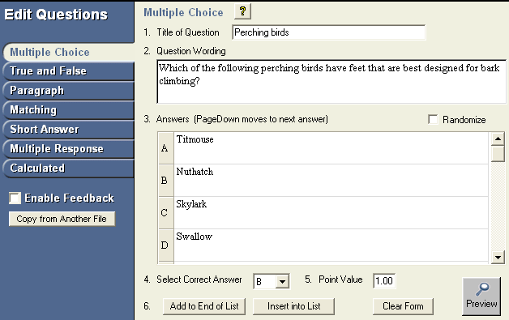
There are seven types of questions: Multiple Choice, True and False, Paragraph, Matching, Short Answer, Multiple Response, and Calculated. Feedback and point values can be added to questions, as can images, multimedia, tables, HTML and various types of enhanced formatting.

The appearance of the Edit menu is dependent on whether you open an exam or a survey file. This is because fewer options are available for survey files (correct answers, point values, and feedback are not used with surveys). The discussion below primarily describes the use of the Edit menu as it relates to exam files.

To create a new question, select the desired question type on the left side of the screen. The entry form on the right side of the screen will change accordingly.

Common Features Among All Question Types
All question types require you to enter a “Title.” The title can be up to 64 characters. If you do not enter a title, Respondus will use the first 20 characters from the “Question Wording” for it.

All question types have a “Question Wording” section. This is where the main body of the question is entered.

Some question types allow the entry of “feedback.” If feedback is enabled for a particular quiz (determined later using the “Settings” menu), students will see the feedback for the answers they selected when they view their graded quiz. To enter feedback for a question (regardless of whether you later decide to have it displayed), select the Enable Feedback option on the left side of the screen. The form will then display fields where feedback can be entered. “General Feedback” can also be entered by clicking the [General Feedback] button and entering the desired information. (Note: If you deselect the Enable Feedback option, all feedback remains stored with the question. It simply does not display the feedback on the Edit screen until the option is reselected.)

Four buttons appear at the bottom of all edit forms. The [Add to End of List] button adds the current question to the end of the “Question List” (located at the bottom of the screen). The [Insert Into List] button lets you insert the current question into the Question List at a specified location. The [Clear Form] button will erase all data that currently shows in the form. Finally, the [Preview] button opens a browser-like window that lets you view how the question will display in the final quiz—feedback and scoring information is also shown in this window. The Preview button can be selected at any stage in the editing process.

Question List and Expanded View
The “Question List” displays the title, question type, points, and question wording for each question in the file. The total number of questions and point values is shown at the top of the list. The first column enables you to preview an item by clicking the magnifying glass icon. The context menu in the next column will display a pop-up dialog with various operations that can be performed on that item.

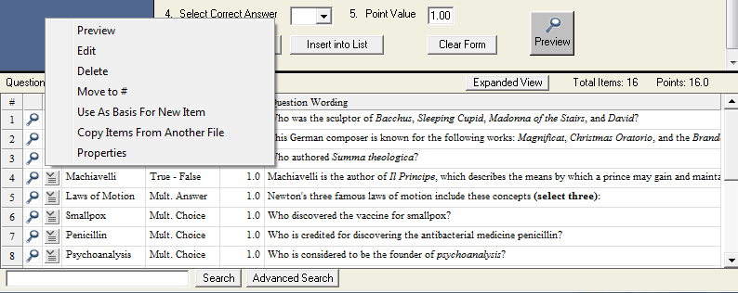

The context menu offers the following operations:

Preview – Preview the item.
Edit – Edit the item.
Delete – Delete the item.
Move to # - Move the item to a new location in the list.
Use As Basis For New Item – Open the item in the edit template and use it as the basis for a new item. The original title will be modified slightly – for example, the number “2” will be added to the end of the name.
Copy Items From Another File – Items can be selected and copied from another Respondus file into the current file.
Properties – Displays a window that summarizes the properties for the item.

The “Expanded View” button, located at the top right of the Question List, displays a full screen pop-up of the question list. This enables you to view more items at once.

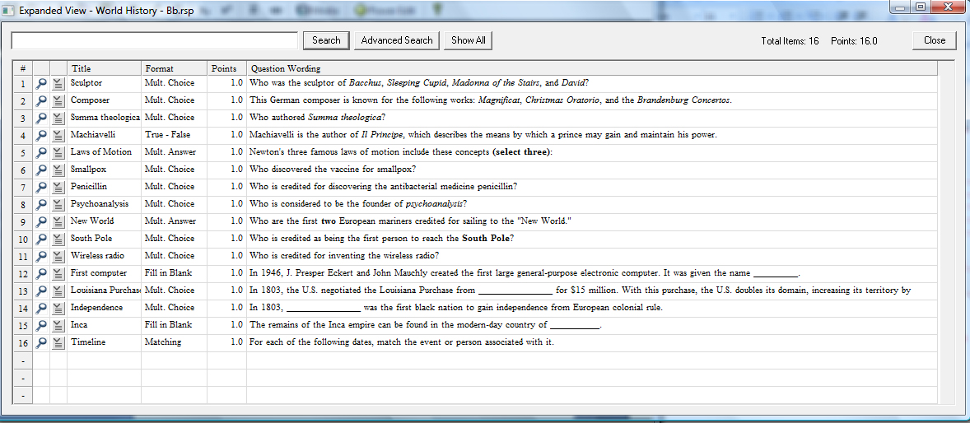

Multiple Choice
Multiple Choice questions in Respondus allow up to 26 answer choices, but only one correct answer can (and must) be selected. You must also provide a point value for each question (the default setting is “1”). Keep in mind, though, that point values can only be transferred to WebCT Server if an actual quiz is uploaded (opposed to just a question bank).

Tip: The easiest way to navigate between the “Answer” fields in Multiple Choice questions is to use the PageUp and PageDown keys.

Answer choices for multiple choice questions can be randomized during a WebCT exam by selecting the “randomize answers” checkbox located just above the answers list. This feature is only supported in WebCT 3.8 and higher.

With survey files, correct answers and point values cannot be included with multiple choice questions. The task does, however, include a “Favorite Answer List” feature that allows you to store frequently used answer sets or scales (e.g., Strongly Agree, Agree, Disagree, Strongly Disagree). To create a Favorite Answer List, enter your answers in the Edit form and click the [Favorite Answer List] button. Then select the option to “Create a new answer list…” and give it a name that allows you to quickly identify it at a later time. From the Edit menu, to use a previously defined answer list, click the [Favorite Answer List] button, select the option “Use the Answer List selected below,” select the answer list you want to use, and click [OK].

With Survey files, the Multiple Choice task also includes a “Multiple Response” checkbox that enables the respondent to select more than one answer.

True and False
With exam files, Respondus provides a separate question type for use with True and False items. This simplifies the editing process for the designer. When questions are transferred to WebCT, the True and False questions are placed in WebCT’s broader “Multiple Choice” category. Similarly, a “Yes and No” question type is available with survey files.

Paragraph
Paragraph question types (also known as “essay” questions) allow students to enter complete sentences or paragraphs for their answer. If the “Enable Feedback” option is turned on, a correct answer can be provided. However, these questions must be graded manually in WebCT.

The paragraph question type includes a “pre-fill Answer box” feature that allows an instructor to enter text that will appear in the answer box when the question is displayed during a quiz. This feature only supports plain text, although you may additionally include an equation if the WebCT Server is version 3.7 or higher.

Matching
Matching questions require students to match items from two columns. There are two ways to create matching questions in Respondus. First, the designer may specify matching pairs for both the left and right columns—specifically, the correct match for the left column must be placed in the field immediately to the right. If this procedure is followed, it is not necessary to indicate the correct answer in the small column located at the far left. (Note it is possible to place extra answers in the right column. In this situation, the extra answers act as decoys and do not match any of the answers in the left column.)

The second approach for creating matching questions allows items in the right column to be placed in any order, but requires the correct answer for the match to be indicated in the small column located at the far left. This approach is especially suited for questions in which a long list of items (e.g., country names) is being matched to a relatively short list of items (e.g., type of government). For example, the left list might contain 25 countries (Afghanistan, Albania, Algeria, Angola, Argentina, etc.) while the list on the right might display four types of government (Multi-Party Democracy, One-Party Regime, Military/Monarchical/Theocratic Regime, Disordered State). Instead of entering the type of government for each country, you can simply enter the letter of the correct answer in front of the country name. See the table below.

Column1 Match Column
D Afghanistan A. Multi-Party Democracy
A Albania B. One-Party Regime
C Algeria C. Military/Monarchical/Theocratic Regime
D Angola D. Disordered State/Civil War
A Argentina
A Austria
A Bahamas
C Bahrain
A Bangladesh
B China
B Cuba

In a matching question, the left column will be displayed to the student in the order information was entered. The right column appears as a list of drop-down menus that students can use to select the appropriate match. Answers in the drop-down menus are randomized.

Tip: The easiest way to navigate through the answer choices is to use the PageUp and PageDown keys. Press the PageDown key twice to move through the “correct match” field.

All answer choices are equally weighted with matching questions. So if a question has 10 matches, each match is worth 10%. There are three choices for grading:

- Proportional to the Number Correct - All answers are equally weighted, without any penalty for incorrect answers. So if a student matches 8 of 10 items correctly, the score would be 80% on that question.

- All Points or None – The student must answer all items correctly in order to receive 100% credit. If any items are missed, no credit is given for the question.

- Right Less Wrong – This option sums the number of correct answers and then subtracts the number of wrong answers. Hence, if the student answers 8 items correctly and two items incorrectly, the score is 6 (8 correct - 2 incorrect).

Short Answer
Short Answer questions (also known as fill-in-the-blank questions) require students to enter a word, short phrase, or string of characters. Since the computer automatically grades the answer, students must give an answer that exactly matches one of the answers provided by the teacher. The standard edit window in Respondus only allows one fill-in-the-blank answer per question. However, it is possible to create questions that have multiple answers (e.g., “Name the first 5 elements of the periodic table”) by clicking the “Advanced” button that appears above the answer grid (this feature is explained later in this section).

Using the standard editing grid, Respondus allows the designer to provide multiple variants of the correct answer. For instance, if the answer to a question is “New York Yankees,” the designer might enter each of the following as an acceptable answer:

Yankees
New York
New York Yankees
NY Yankees

Two types of credit can be given for short answer questions. The “Equals” (exact match) option requires the student to type an exact word or phrase, but ignores capitalization. The “Contains” option also requires the user to type an exact word or phrase, but it ignores extra words or characters that appear before or after the answer provided by the instructor. In addition, this option is case sensitive. (Note that the “regular expression” option is available for users who want to implement Perl scripting language for determining credit for short answer questions. The use of this feature is beyond the scope of this user guide.)

Short Answer - Advanced
The “Advanced” button that appears above the answer grid in the short answer editor allows the creation of more sophisticated short answer questions. First, more than one correct answer can be required of the student (e.g., “Enter the names of the first two men who walked on the moon?”). Second, the order of the correct answers can be specified (e.g., “In the first blank enter the name of the first man to walk the moon. In the second blank enter the name of the second man to walk on the moon.”). Third, it is possible to assign different point values for each answer choice (e.g., Neil Armstrong = 40% of the point value, Buzz Aldrin = 60% of the point value).

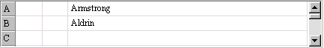To begin, click the “Advanced” button to change the standard answer grid to the advanced answer grid. If the question requires students to fill in two or more answer blanks, but the order in which the answers are entered doesn’t matter, then simply list each correct answer in the wide grid section at the right.

However, if the question requires students to fill in two or more answers, and the order in which the answers are entered does matter, then the middle column in the grid should be used to specify the position of each correct answer. For example, if the first answer must be entered as “Armstrong” and the second answer must be entered as “Aldrin,” then the grid should look like this:
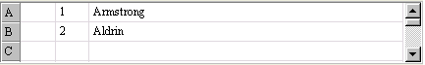
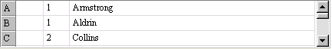If you want to allow multiple variants for each correct answer, that too can be accomplished if each answer choice has a specified order. For example, consider the following question: “In the first blank below, enter the name of either astronaut who walked on the moon as part of the Apollo 11 mission. In the second blank, provide the name of the astronaut who orbited around the moon in the mother ship, but never walked on the moon.”

Finally, it is possible to distribute the point value for each correct answer according to the percentages specified in the leftmost column. For example, if the total point value for the following question is worth 10 points, the instructor might assign one answer a higher percentage of these points: “Who were the first two astronauts to walk on the moon?”
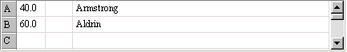

In this example, students who provide the correct answer of “Armstrong,” but do not provide the correct answer of “Aldrin,” will only receive 40% of the point value (in this case 4 of 10 points).

Multiple Response
Respondus provides a separate question type for multiple choice questions that have more than one correct answer. The Multiple Response question type is very similar to Multiple Choice questions, except that students can (and should) select more than one correct answer. (When multiple response questions are transferred to WebCT, they are placed in WebCT’s broader “Multiple Choice” category.)

Tip: The easiest way to navigate through the answer choices is to use the PageUp and PageDown keys. Press the PageDown key twice to move through the “correct answer” field.

Answer choices for multiple response questions can be randomized during a WebCT exam by selecting the “randomize answers” checkbox located just above the answers list. This feature is only supported in WebCT 3.8 and higher.

In the column that precedes the answer choices, the letter “X” should be entered for all correct answers. WebCT will assign equal value to all answers indicated as correct. Thus, if two of four answers are marked as correct , each correct answer will be worth 50% of the point value. If the designer selects three of four answers as being correct, each correct answer will be worth 33.3%.

It is also necessary to select the type of “Credit Given” for correct and incorrect answers. Respondus offers two choices: “Right Less Wrong” and “All Points or None”. The “All Points or None” setting is straightforward: if any portion of the answer is wrong, no points will be awarded for the question. If the “Right Less Wrong” option is selected, incorrect choices are subtracted from correct choices. For example, if a student accurately selects the two answers out of four that are correct, but additionally selects a third answer that is wrong, she would receive 100% for answering the two questions correctly, minus 50% for the incorrect answer (for a total score of 50%). It should be noted that the default setting in Respondus prevents the final point value for a question from being negative (thereby preventing a student from losing points for answering the question incorrectly). This setting can be overwritten once questions are published to WebCT.

Entering Percentage Values for Each Answer
With Multiple Response questions, it is also possible to assign exact values for each correct and incorrect answer. Instead of placing an “X” in front of the correct answers, values totaling 100% for the correct answers can be entered. Conversely, negative values totaling –100% can be entered for the incorrect answers. The logic for this can be confusing at first, but the best approach is to simply remember that the correct answers should total 100% and the wrong answers should total –100%. For example, if answers A and C are correct and answers B and D are incorrect, you might assign values as follows:

50% A) Answer A (correct)
-50% B) Answer B (wrong)
50% C) Answer C (correct)
-50% D) Answer D (wrong)

In fact, this matches what Respondus does automatically when you enter “X” for the correct answers. However, it is also possible to place unequal weights on right and wrong answers, although one should do so carefully.

60% A) Answer A (correct)
-70% B) Answer B (wrong)
40% C) Answer C (correct)
-30% D) Answer D (wrong)

For this type of grading, be sure to select the “Right Less Wrong” setting for the “Credit Given” option. Also remember that the default setting in Respondus prevents the overall point value for a question from being negative (thereby preventing students from losing points for answering the question incorrectly). This setting can be overwritten once questions are published to WebCT.

Again, the best approach is to make sure that correct answers total 100% and wrong answers total –100%. Incidentally, if you only assign positive values for the correct answers and leave wrong answers as zero, students will be able to select all answers for a question and obtain 100% credit. Use this option carefully!

Calculated
Calculated questions require students to apply a mathematical formula to answer the question. Calculated questions are designed using variables. Random values, based on a specified range, are automatically generated for each variable in the question. Thus, calculated questions can be unique for each student, as illustrate in this example where values are inserted for {x} and {y}.

Example: If a car is traveling {x} miles per hour for {y} hours, how far does it travel (in miles)?

The Respondus editor for Calculated questions contains the following sections that need to be completed:

- Question Wording
- Formula
- Variable Properties
- Answer Properties
- Value/Answer Sets

Calculated – Question Wording
In the Question Wording section, enter the text of the question just as you would for any other question type. However, instead of using specific numerical values to define the details of the question, instead use variables by specifying a name enclosed in curly brackets for each one. For example: “How long does it take to travel {x} miles at a speed of {y} mph?”

Variable names can only contain letters and digits (the characters 0-9, a-z, and A-Z), and the “_ “ (underscore) character. In addition, the first character of a variable name cannot be a number.

You can use as many different variables as you need to define the question, and you can use the same variable name multiple times if necessary.

Calculated - Formula
In the Formula section, enter the mathematical formula associated with the question. This is the same formula that the student will be expected to use, and the same one that will be used to automatically calculate the correct answer for grading purposes. The same variables specified in the question wording will be used to indicate where each value should go in the formula.

The formula can be typed into the edit field directly, or entered by selecting options from the pull-down lists provided for Variables, Functions, Operators, and Constants. Selected options will appear in the edit field at the current cursor location, and will overwrite the current selection (if any).

The “Variables” list provides an easy way to select a common variable name.

The “Functions” list provides the following supported mathematical functions:

abs(x) Absolute value of x. abs(-3) = 3.
acos(x) Arc-cosine of x in radians
asin(x) Arc-sine of x in radians
atan(x) Arc-tangent of x in radians
atan2(x,y) Arc-tangent of x/y in radians. Uses signs to determine result quadrant.
ceil(x) Round x up to the nearest integer. ceil(2.1) = 3. ceil(-2.1) = -2.
cos(x) Cosine of x in radians
cosh(x) Hyperbolic cosine of x in radians
exp(x) Base e (Euler’s constant) raised to the power of x
fact(x) Factorial of x. fact(3) = 6.
floor(x) Round x down to nearest integer. floor(2.8) = 2. floor(-2.8) = -3.
int(x) Return integer portion of x. int(4.32) = 4. int(-4.32) = -4.
ln(x) Base e natural logarithm of x
log(x) Same as ln(x)
log10(x) Base 10 logarithm of x
max(x,y,…) Return the maximum of all supplied arguments. max(1,2,3) = 3.
min(x,y,…) Return the minimum of all supplied arguments. min(1,2,3) = 1.
round(d,x) Round x to d decimal places. Halfway cases round away from 0.
sin(x) Sine of x in radians
sinh(x) Hyperbolic sine of x in radians
sqrt(x) Square root. sqrt(9) = 3.
tan(x) Tangent of x in radians
tanh(x) Hyperbolic tangent of x in radians

Note that the values for trigonometric functions are expressed in radians, not degrees. For conversion purposes, Pi radians = 180 degrees. Also, for all formulas that have two correct answers (for example, the square root of 9 is +3 and -3), only the positive number will be treated as correct.

After selecting a function from the list, the formula must be edited to replace the argument list with numbers or variables. For example, “round(d,x)” might be edited to specify a fixed number of decimal places and a variable to round, as in “round(3,{y})”, which would round the variable {y} to 3 decimal places.

Functions can also be nested within a formula, as in “sqrt(abs({x}))”. In this case, the absolute value of {x} is evaluated first, followed by the square root of the result. Functions can be nested as deeply as necessary to properly calculate the answer.

When entering numerical values, scientific notation is expressed in the format xEy, where x is the coefficient and y is the exponent. To convert numbers from scientific notation to standard notation, use x times 10 to the power of y. For example:

- 3.2E4 equals 32000
- -2E0 equals -2
- 3.14E-2 equals 0.0314

The “Operators” list provides the following standard mathematical operators:

- Subtraction
! Factorial. For example, 3! = 6. Enclose variables in parentheses, as in ({x})!
% Modulus or remainder. For example, 5%2 = 1.
() Parentheses used to group elements for precedence
* Multiplication
** Power or exponent. For example, 2**3 = 8.
/ Division
+ Addition

The “Constants” list provides the following commonly-used numerical constants:

_e Base e or Euler’s constant (2.71828…)
_pi Pi – the circle ratio (3.14159…)

Some example questions and associated formulas might be:

Question: How long does it take to travel {x} miles at a speed of {y} mph?
Formula: {x}/{y}

Question: What is the positive square root of {x}?
Formula: sqrt({x})

Question: Compute sin(x) where x = {x} degrees.
Formula: sin({x}/180*_pi)

Calculated - Variable Properties
Clicking the “Variable Properties” button in the Formula section displays the Variable Properties dialog. Here, each variable in the question wording and formula is listed by name, along with Minimum, Maximum, and Precision values for that variable.

The Minimum and Maximum define the range of values each variable can be assigned, and the Precision specifies the number of decimal places each value should be allowed before the value is rounded off.

You can click each cell in the grid to edit the specific minimum, maximum, or precision value you want to change (the variable names cannot be edited). In general, for a given variable the minimum must be less than or equal to the maximum, and the precision must be greater than or equal to 0 and less than or equal to 5.

Calculated - Answer Properties
Clicking the “Answer Properties” button in the Formula section displays the Answer Properties dialog. Here you can specify values for answer precision and acceptable tolerance, as well as a unit name and associated score percentage.

Answer precision can be specified in Decimal Places or Significant Figures. If the precision is specified in decimal places, the value must be greater than or equal to 0 and less than or equal to 5, just as with the precision values specified in the Variable Properties dialog. If the precision is specified in significant figures, the minimum value is 1.

Answer tolerance is the amount that the student’s answer can deviate from the calculated answer and still be considered correct. It can be specified as a fixed number of units or as a percentage of the answer value.

If you choose to require a unit name, you must enter a unit name and a percentage of the total question score that the correct name will be worth. Comparisons with the name entered by the student will be case-insensitive and space-insensitive. The score percentage must be greater than or equal to 0 and less than or equal to 100.

Calculated - Value/Answer Sets
Clicking the “Value/Answer Sets” button below the Formula section displays the Value/Answer Sets dialog. Here you can generate sets of variable values and calculate the associated answers using the formula previously entered. When the Calculated question is presented to the student, one of these value sets will be randomly chosen to populate the variables in the question wording and the formula, and the associated answer will be used to grade the student’s response.

The grid displays a list of numbered value/answer sets. The number of sets available can be selected from the “Number of Sets” pull-down list. For each set, the generated values for each variable are shown, and the individual cells can be clicked to edit those values. Note that any manually-entered values must be within the range specified by the variable minimum and maximum in the Variable Properties dialog. The answers cannot be edited; instead, the “Update Answers” button can be clicked to recalculate the answers for all value sets.

Adding Bold, Italics, Underline, and Super/Subscript
Respondus makes it easy to add enhanced formatting to question wordings, answers, and feedback. The bold, italic, and underline tasks work just like a standard word processor. Simply highlight the text you want to modify and click the appropriate [B], [I], or [U] button on the tool bar. The text will immediately change to the selected formatting. The superscript [X²] and subscript [X₂] tools function in the same manner. To remove any of the above-mentioned formatting, simply highlight the text again and reselect the corresponding button from the toolbar.
(Please note that although the underlying “HTML tags” are not displayed in Respondus, these tags will be transferred to -- and displayed by -- WebCT Server when the file is uploaded.)

Media Wizard
One of the more powerful features in Respondus is the ease in which media (e.g., images, audio clips, video clips), attachments (e.g., spreadsheets) and links can be added to exams. Media content can be added to question wordings, answer choices, and feedback without writing or viewing HTML. In addition, the media objects can be previewed offline, and everything is automatically uploaded to the WebCT server during the Publish process.

From the Edit menu, position the cursor at the place in the question where you want the media item added. Then click the “Media” icon on the toolbar. A pop-up wizard will guide you through the selection of the media element.

The first step is to choose whether the media is being uploaded from a local computer or being linked to on the Internet. If the media file is located on your computer, the next step is to select the type of media being attached; image (.jpg, .bmp, .gif, .png, .pcx, .emf), audio/video file (.mpg, .avi, .wav, .mov, .swf) or other file type (.docx, .pdf, etc.).

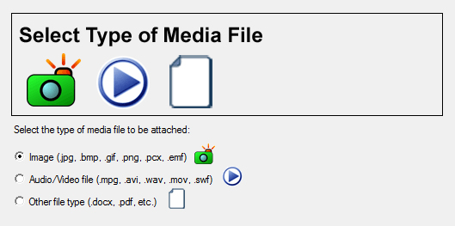

If images are selected, the Media Wizard will enable the entering of “alt text” (for screen reader applications) and will allow you to specify a scaling factor so that large images can be scaled to a smaller size.

When an Audio/Video file is attached to a question, the appropriate media player is automatically selected and you are given the option to insert it as an embedded object or a linked object.
If “Other file type” is selected, the file is displayed as a web link during the exam and the file can be viewed using a browser plugin or will launch another application that’s associated with that file type.

If external media is selected, the next step of the Media Wizard is to select an Image or Picture (Google Picasa Image or an image located at a URL) or Audio/Video file (YouTube video or an audio/video file located at a URL).

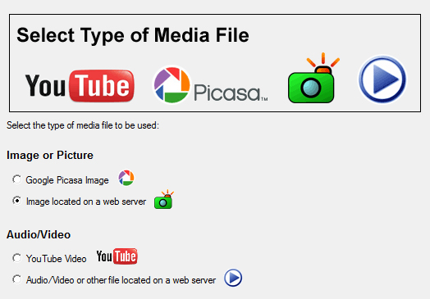

If Google Picasa images or YouTube videos are selected then the Media Wizard provides a search interface that allows you to search, preview, and select images and videos from the associated web sites for embedding or linking in the exam. Videos and images that are located on an external web server can also be manually linked to the exam.

Updating and deleting items added with the Media Wizard is as easy as clicking on the media icon that appears in the editor. When you select a previously added media element, a context menu will appear that allows you to update or delete the item.

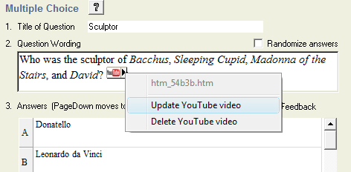

HTML Editor
Even course designers who are comfortable writing HTML often have difficulty sorting out the HTML they’ve written from the question wording itself. Respondus solves this problem by encapsulating blocks of HTML so that the question wording stays the focus of the screen. The only time a designer has to view HTML is while the Respondus HTML Editor is being used.

From the Edit menu in Respondus, position the cursor at the location in the question where you want to begin a block of HTML. Then click the “HTML Editor” icon on the toolbar (represented by the symbol <H>) to open the editor. Enter your HTML by typing or pasting it into the editor--it is also possible to retrieve the HTML from a file located elsewhere on your hard drive by using the “Read File” option. Click [OK] to close the HTML Editor. A set of characters representing the HTML block will appear at the insertion point: <H_1> for the first block, <H_2> for the second block, and so on. To see how the HTML will appear in WebCT, click the preview button.

To delete an HTML block, position the cursor in the same field where the HTML block is located, and select the “HTML Editor” icon from the toolbar. Choose the option to delete the HTML block and highlight the block you want to delete. Click [OK] to close the HTML Editor.

Equation Editor
The process of adding equations is similar to how media objects are added (see the earlier discussion). Equations can be added to question wordings, answer choices, and feedback, all without writing HTML. In addition, the equations can be previewed offline and they are automatically uploaded to the WebCT server during the Publish process.

From the Edit menu, position the cursor at the place in the question where you want the equation located. Then click the “Equation Editor” button on the toolbar, which is represented by a summation symbol. The Equation Editor will open and you can begin creating the equation. The Equation Editor in Respondus works almost identically to the one that is available with Microsoft Word and WordPerfect. So if you’ve used those equation editors before, you’ll already know how to use this one. The key thing to learn about the Equation Editor is that the top row of menu options consist of “symbols” while the bottom row of menu options consist of “palettes”. If you select a “symbol” from the top row, it’s no different than if you selected the + or = sign on your keyboard -- except that the symbols from the Equation Editor eventually get displayed as graphics since they are not HTML-compatible. When you select a “palette” from the bottom row, you are given the opportunity to enter text at various insertion points shown on the screen. You can also select a palette from the bottom row, click in an insertion point, and then select a symbol from the top row. For more information about the Equation Editor, refer to the online help that is available from within the editor.

Once you finish editing the equation, exit the Equation Editor by either clicking the [X] that appears at the top right corner of the window or by selecting File from the pull-down menu and clicking Exit. A second window that addresses other properties of the equation will now appear. The font selection and size used within the Equation Editor determines how large the equation will be when it is printed from Respondus. But it is generally desirable to show equations in a larger format when displaying them on the web. In general, we recommend that a web-based equation be displayed at 150% of the size used for printing. So by default, the Respondus software suggests that the “WebCT Image Scaling” for the equation be increased to 150%. To accept this setting, simply click the [OK] button. If you want the graphic to appear even larger in WebCT, then you can increase the scale to up to 400%. It’s important to note that changing the image scale using this option only affects how it will appear in WebCT--you are NOT affecting the size of the equation that will print from Respondus. In order to change the size of the equation for printing purposes, you must select a different font size in the equation editor itself. It should also be noted that the image scaling only applies to equations that are uploaded to WebCT as images. If the Preference settings in Respondus are set so that equations are uploaded to WebCT as MathML or a WebEQ-compatible format, then the image scaling information is ignored during the upload.

Lower on the screen is an option that is only applicable to equations being uploaded to WebCT in a MathML or WebEQ-compatible format. With some MathML equations, it is necessary to adjust the width of the blank space that appears to the right of the equation. In some situations you need to add more spacing so the equation itself doesn’t get “clipped.” In other situations you may want to reduce the amount of space that appears after the equation so that a gap doesn’t appear between the end of the equation and the text that follows. Respondus allows you to adjust the pixel width that appears after MathML / WebEQ equations by adding a positive number (to increase the space) or a negative number (to decrease the space). For example, if you enter the number -25, the space after the equation will be reduced by 25 pixels.

An additional “Alt” field allows a text description to be added to the equation image so it can be utilized by an ADA-compliant screen reading browser. This text is also displayed when the mouse pointer is held over the image. If you simply click [OK] to close the window, the generic text “equation” will be used for the “alt” field. If an expanded textual description is entered (such as “b is greater than or equal to c”), it will be used by the screen reader instead. Keep in mind that the “Alt” field only applies to equations that are uploaded to WebCT as images. If the Preference settings in Respondus are set so that equations are uploaded to WebCT as MathML or a WebEQ-compatible format, then the “alt” text is no longer applicable.

Once an equation has been added and you return to the Edit menu, a short string of characters representing the equation object will appear in green text. An equation placed in the question wording will look something like <EQ_1>, with the next equation being displayed as <EQ_2>, and so on. When an equation is placed in an answer choice or feedback, it will appear as a small red box, except when that field is being edited.

To modify or delete an equation, position the cursor in the same field where the equation is located. Then click the “Equation Editor” icon on the toolbar and select the option to modify or delete an existing equation. If you simply want to adjust the spacing that appears after a MathML equation, select the option “Adjust spacing following an equation.”

You can preview questions containing equations by selecting the [Preview] button. We recommend that you preview all equations before publishing them to the WebCT server.

Using MathType with Respondus
The Equation Editor in Respondus is a special version of MathTypeTM by Design Science. If you frequently create documents with equations, you may find MathType is better suited to your needs. MathType is as easy to use as the Equation Editor and has many extra features to help you save time and create a wider range of equations.

MathType is available in English, Japanese, German and French. For further information about purchasing MathType, contact your software dealer or Design Science directly: Design Science, Inc., 4028 Broadway, Long Beach, CA 90803, USA.

Toll free: 800-827-0685 International: 562-433-0685
Fax: 562-433-6969
Email: sales@dessci.com
World Wide Web: http://www.dessci.com

If you already own MathType, you will need to reinstall it in order to have it work directly with Respondus. MathType's readme file explains that it sets itself up to replace Equation Editor at the time that it's installed. So if you add a new application like Respondus that uses the Equation Editor, you must re-install MathType.

Using MathType 5 to create MathML and WebEQ-compatible Equations
Respondus includes special features that are designed to work specifically with MathType 5 and WebCT’s implementation of the WebEQ equation editor in WebCT 3.7 and higher.

MathType 5 allows you to create equations and save them in MathML format. MathML is an XML-based language that requires a MathML “plug-in” to be installed to a web browser to display the symbols. By default, Respondus will store equations created by the built-in Equation Editor or MathType as image files. However, if an instructor uses MathType 5 (or higher) in conjunction with Respondus, it is possible to have equations uploaded to WebCT as MathML instead of images. This setting can be determined in Respondus by going to the File menu, selecting Preferences, and then selecting the option “MathML applet for all equations.”

MathType 5 users can additionally use Respondus to create equations that are compatible with the built-in equation editor in WebCT 3.7 and higher. Since WebCT’s built-in equation editor (WebEQ) cannot be used in all areas of assessments, Respondus offers a hybrid approach -- that is, one that uses images or MathML applets in areas where WebEQ equations cannot be used. To select a WebEQ setting in Respondus, go to the File menu, select Preferences, and then select either the WebEQ+Image setting or the WebEQ+MathML option. Again, the WebEQ settings in Respondus should only be selected if the questions are being published to WebCT 3.7 or higher.

It’s important to note that it is unnecessary to specify the format of the equation (i.e., image, MathML, WebEQ hybrid) prior to creating the equation in Respondus. Rather, the preference settings in Respondus only affect how the equation will be uploaded to WebCT in the publishing step, and how it will be previewed in Respondus.

For current and detailed information on creating equations in Respondus (including topics related to MathType, MathML, WebEQ, MathML plug-ins), go to the Support section of www.respondus.com and select the FAQ link.

Power Edit
The “Power Edit” task available from the Edit menu provides additional features for formatting questions, including a table editor, bulleted lists, the ability to change fonts and justification, and so forth. In addition, the Power Edit window provides a much larger workspace, which is especially useful if you are creating tables or editing questions that have large blocks of text.

To begin, click in the field that you want to edit and then click the “Power Edit” button on the toolbar. Several of the tasks on the Power Edit toolbar also appear on the main toolbar, so only the unique features will be discussed below.

Tables
Respondus makes it easy to insert and edit tables. From the Edit menu in Respondus, position the cursor at the location where you want to insert the table. Then click the “Power Edit” button and select the “Insert Table” icon from the toolbar (located at the top right). When the next pop-up window appears, specify the number of columns and rows that should be included in the table (all other settings are optional). Click the [OK] button to return to the Power Edit window. You can now click within the cells of the table and enter the text.

The width of the table cells can be adjusted by dragging the column lines. To edit other dimensions of the table from the Power Edit menu, click within the table and select the desired action from the pull-down menu labeled “Table.” Use the “Insert” option to add a row or column to the table. Use the “Delete” option to delete a row or column, or to delete the entire table. Other formatting (such as font changes and the centering of text) can also be applied to the cells in a table.

Finally, keep in mind that it is usually possible to paste tables into Respondus directly from Microsoft Word. Also, Respondus tables are designed to support both web-based exams and print exams. So you only have to create a table once if you require both online and print exams.

Fonts, Formatting, and Lists
The remaining features in the Power Edit task are self-evident if you are familiar with the basic functioning of a word processor. To apply a different font to text, simply highlight the text and select the desired font and size from the pull-down lists. Text can be left justified (the default), right justified, and centered by selecting the appropriate toolbar button. Finally, it is easy to create bulleted or numbered lists by selecting the corresponding option from the Power Edit toolbar.

To see how the formatting will appear in WebCT, click the preview button that is located at the top left of the Power Edit toolbar. To exit the Power Edit window, simply click the [X] at the top right corner of the window, or go to File and click Save & Exit.

Spell Check
The Spell Check feature, which is located on the toolbar for the Edit menu, will search the currently open file for spelling errors and allow corrections to be made. Once the Spell Check feature is started, it will search for words that do not match items stored in the dictionary. If the word is not found in the dictionary, you are given the option to “Change” the word to one that is suggested, to “Ignore” the identified word, to “Change All” such words in the file to one you select, or to “Add” the word to the dictionary. If you want to make more detailed changes to the question, click the “Edit This Question” button, which will close the spell checker and make the question available for editing.

Three dictionaries are included with a standard installation of Respondus: American English, Canadian English, and British English. However, a free bundle of supplemental dictionaries can be downloaded from the Respondus website, including French, German, Spanish, Dutch, Finnish, and a comprehensive medical dictionary.

Keyword Searches
There are several places in Respondus where the [Search] and [Advanced Search] buttons appears, such as at the bottom of the Edit and Expanded View menus. A quick search can be performed by entering a search term in the field next to the [Search] button. The [Advanced Search] option also allows you to search the currently open file, or the file that is being previewed.

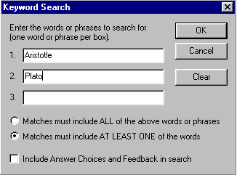
Up to three words can be included in an Advanced Search. When more than one word is used, you can choose whether a match is required of all words or any of the words. A final option allows you to include answer choices and feedback in the keyword search.

Settings Menu
Overview
Question Sets
Basic Settings
Availability Settings
Security Settings
Submissions Settings
Results Settings
How to Save New Default Settings

Overview
Respondus allows the selection of settings for a quiz or survey prior to it being uploading to WebCT. Although this step is entirely optional, it provides the ability to create “question sets” and to determine the settings for the quiz offline. It’s even possible to have a quiz activated as soon as it is published to the WebCT course.

The “Question Sets” task has an entirely unique approach and design to it than that used by WebCT. However, the three other Settings tabs in Respondus are designed almost identically to how they appear in WebCT. The main difference is that Respondus distributes these settings across several tabs instead of listing them in one long form. Rather than write an entirely new explanation for the Settings options that are almost identical to how they work in WebCT, we have borrowed (with WebCT’s permission) much of their on-line help for this section.

Finally, please note that the discussion below focuses on the settings for quizzes. Some of these settings are not relevant to surveys, such as the “Results Settings.” If you are using a survey file, only the settings available for WebCT surveys will be displayed.

Question Sets
WebCT supports the creation of “question sets,” which are groupings of questions that are randomly selected during an exam. Before creating question sets in Respondus, it is important that questions intended for question sets be organized and grouped properly. For example, if the fifth question in the exam is going to be randomly selected from a question set having three questions, then those three questions should be grouped together at 5, 6, and 7 in the file. Make sure your questions are organized in this manner before continuing.

To create a question set, go to the Settings menu and select the “Question Sets” tab.
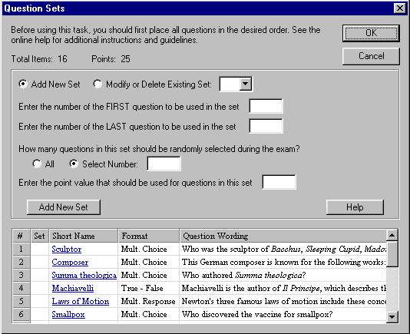

Then select the option “Add New Set” and enter the first and last numbers -- that is, the range -- of the questions that will comprise the question set. For instance, if you want questions 5, 6, and 7 to be the basis of a question set, you would enter 5 as the first question and 7 as the last question in the set.

If you want all of the questions in the set to be shown during the exam, select the “All” option. If, however, you want a smaller number of questions from the set asked during the exam, choose the “Select Number” option and provide the desired number. For example, if you want only one question from questions 5-7 asked during the exam, you would enter the number 1. You are then asked to provide a point value for the question set. (All questions in a question set must have the same point value.)

Finally, click the “Add New Set” button to finish the creation of the question set. In the list below, a letter representing the question set will appear next to each question that is contained in the question set. This allows you to easily see which questions are grouped together.

The letters representing each question set also provide the basis for editing a question set. For instance, if the letter “C” appears next to a set of questions, and you want to edit this particular question set, select the option “Modify or Delete Existing Set” and select “C” from the pull-down list. The current settings for that question set will be displayed and several new options will appear in the lower section of the screen: Save Changes, Cancel Changes, and Delete Set.

In order for question sets to be included with the quiz when it is published to WebCT, you must select the checkbox “Add Question Sets to Quiz” on the Publish to WebCT menu. Conversely, if you do not want question sets included with the quiz when it is published to WebCT, leave this box unchecked.

Basic Settings
The section labeled Basic Settings includes settings that must be considered for most quizzes and surveys.
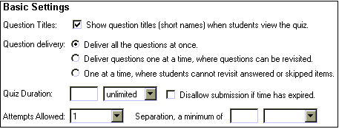

Question Titles
Select this check box to allow students to see the titles used when the questions were first created.

Question Delivery
There are three options available for question delivery. They are explained in the same order as displayed in the graphic above.

- The first option corresponds to the standard option, which is to display all of the questions simultaneously on the screen. This method follows the delivery method of a paper exam where a student may view and answer questions in any order.
- The second option provides the same flexibility to the student as option one, but displays only one question on the screen at a time.
- The third option is very different from the first two options. Like the second option, this option displays one question at a time; however, students must answer or skip each question before proceeding to the next question. Once a question has been answered or skipped, the student cannot revisit the question.

Quiz Duration (Quizzes only)
The duration is the length of time the student has to complete the quiz. The clock starts when a student first accesses the quiz.

To set the duration for the quiz, select the units (day(s), hour(s), or minute(s)) from the drop-down menu and then type the number of desired units in the text box. To give students unlimited time on a quiz, select the “unlimited” option from the pull-down menu and do not specify any units in the text box.

Normally, the student may submit answers after time has expired. All of these events are logged so that it is easy to determine which students exceeded the set time limit, and by how much. You may set the quiz so that students cannot submit answers after their time is up. To do this, click the check box labeled Disallow submission if time has expired.

Warning: Use this feature with caution. This feature will not take into account that a student spent 30 minutes composing an answer and then attempted to submit the answer after the set time limit; the submission will not be allowed, so all the work will be lost. If this function is used, warn the students to save their work frequently by clicking Save Answer.

Attempts Allowed (Quizzes only)
This setting determines the number of times a student may complete a quiz—this may be set from one to five, or to unlimited. Select your choice from the drop-down menu.

Note: For the purpose of compiling question statistics, only the first attempt is recorded.

Attempts Separation (Quizzes only)
For quizzes that allow multiple attempts, you can set a minimum time that the student must wait before retaking the test. To set the duration, select the units (day(s), hour(s), or minute(s)) from the drop-down menu, and enter the number of units in the text box. If you do not enter a value, then there is no waiting period before a student can retake a test.

Availability Settings
The Availability Settings must be considered for every quiz and survey. These settings describe the time period in which the quiz or survey will be available to the students.

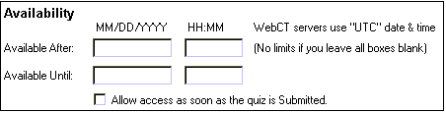
Available After
To set the start point of the quiz/survey availability period, fill in the text boxes for day, month, and year, and choose a time from the selection boxes for hour and minute. If any of the values for day, month, and year are zero, then the quiz/survey will not be released. However, if you want to activate the quiz/survey as soon as it is published to WebCT, select the option “Allow access as soon as the quiz is submitted.”

It is important to remember that the “time” on the server may not match your own time. For example, WebCT Inc. uses the Universal Time Code (UTC) for courses that are hosted on their servers. If you are not comfortable calculating the difference between your time zone and the UTC, you may want to avoid tight time limitations for administering quizzes. Also, remember that the UTC doesn’t adjust their clocks for “Daylight Savings” and other time-related events used in certain countries.

Available Until
To set the end point of the quiz/survey availability period, fill in the text boxes for day, month, and year, and choose a time from the selection boxes for hour and minute. If any of the values for day, month, and year are zero, the quiz availability will be Unlimited.

To make a quiz/survey immediately unavailable, you will need to go to the Quiz Settings section in WebCT and select the “Deny Access Now” button.

Selective Release
Respondus does not allow you to determine the Selective Release Settings offline. If you want to use these settings, you must make the changes on the WebCT server using your browser.

Security Settings
The Security Settings are optional. They may be used to restrict access to the quiz/survey for security purposes. The settings do not change the Availability of the quiz/survey, they only change how it is accessed.
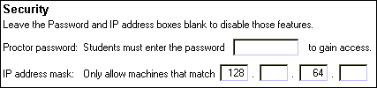

Proctor Password
If nothing is entered in the text box, your students may access the quiz normally. Otherwise, your students will be asked for a password before entering the quiz. To successfully enter the quiz, the password the student enters must exactly match the text in the text box. This method is often used with proctored exams given in lab settings, as the exam proctor will give out the password at the beginning of the exam. This ensures that the correct students are accessing the quiz at the proper time.

IP Address Mask
In order to limit quiz access to those coming from a specific group of computers, an IP address mask may be used. If nothing is entered in the IP Mask Number text box, then all computers can access a quiz (if available). In the example illustrated above, a student trying to access the quiz from a computer with an IP address of 128.192.64.37 will be allowed access, but a student accessing from 128.192.32.39 will not be allowed access, since the 32 from the student's IP address does not match the 64 in the IP address mask.

Submission Settings
The Submission Settings are optional. These settings affect the behavior at the time a quiz or survey is submitted by the student.

Submission Message
Any text entered in the text box will be displayed to the student after the quiz or survey has been submitted.

E-mail Submissions
If a valid internet e-mail address is entered in the text box, a text only copy of each student's submitted quiz will be sent to the e-mail address.

Results Settings (Quizzes only)
The Results Settings in this section are required for quizzes. These settings affect the behavior of a quiz after it has been submitted.

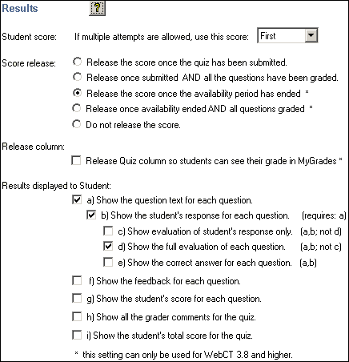

Student Score
If you allow your students to attempt the quiz multiple times, then this setting will determine how WebCT calculates the quiz score. The selection box can be set to use the First, Latest, Highest, or Average score to calculate your students' score for a quiz.

Note: Only fully graded quizzes are used in the score calculation. Quizzes that are not graded or are partially graded are not included in the calculation.

Note: For question statistics, only the first attempt is recorded.

Student Score Release
This setting is used to set the conditions that will allow a student to view the quiz after it has been submitted. Note that when a student views a quiz, this causes it to be graded.

There are three options available for the release of quiz results to your students.

- The first option releases the quiz results to your students with no restrictions. If the quiz includes questions that cannot be marked automatically, the graded quiz will only be partially graded when viewed by the student.

- The second option releases the quiz to your students only if all the questions have been graded. Thus, if all of the questions in a quiz can be graded automatically, the student will be able to view the graded quiz immediately. If the quiz includes questions that cannot be graded automatically, then your student can view the graded quiz only when all of the questions have been graded.

- The third option does not release the quiz results to the students. Thus, the students will not be able to review the quiz after taking it.

Note: These options may be changed at any time in WebCT (using a browser). For example, if a quiz includes questions that cannot be graded automatically, it is often useful to select option three. Then, once all the quizzes have been fully graded, one of the first two options can be selected. Remember that once a quiz has been submitted to WebCT and accessed by students, you can no longer use Respondus to make modifications or changes to the quiz. This must be done directly at the WebCT server using a browser.

Results Displayed to Students
These check boxes determine the amount of quiz information that WebCT will display to a student. These settings will not be in effect if you have not released the quiz results. The basic parts of each question that can be toggled on and off are: the text of the question itself, the feedback for the question, and the student’s score for the question. If the question text is being displayed, your student’s response may also be shown. If the response is shown, an evaluation of the question may also be shown. For the entire quiz, the total score and any comments entered by a grader may be displayed.

The default configuration shows the student everything. To duplicate the appearance of the quiz as a student took it, select only option “A”. To show no information about the quiz other than the final score, select only option “I”.

How To Save New Default Settings
In Respondus there are two types of default settings: the original settings as provided by WebCT, and a second set of default settings that you can determine yourself. To save your own default settings, select the options you want across the three setting tabs (Basic & Availability, Security & Submissions, and Results). Then click the [Use as New Defaults] button on the left side of the screen. From this point forward, all new files created in Respondus will have the new default settings attached to them.

If you make modifications to the settings and later wish to restore the default settings (either your own default settings, or WebCT’s), simply click the [Restore Default Settings] button. You will be asked which settings you want to restore.

Preview & Publish
Overview
Preview
Publish to WebCT
Add WebCT Self-Test
Update Settings
Printing Options

Overview
Once an exam or survey is created in Respondus, the Preview and Publish menu let’s you determine what to do with the file. Most users will first want to examine the contents of the file using the Preview task. When the questions are ready to be uploaded, the Publish to WebCT task connects Respondus to a WebCT server and transfers the exam or survey to it. An exam file can also be published as a “self-test” using the Add WebCT Self-Test submenu. Finally, the Print task lets you format and print the exam or survey directly from Respondus, or you can bring a file into a word processor for further enhancement and printing.

Preview
The Preview task, located on the Preview & Publish menu, is similar to the preview option that appears in the Edit menu. The primary difference is that here you can easily scroll from one question to the next.

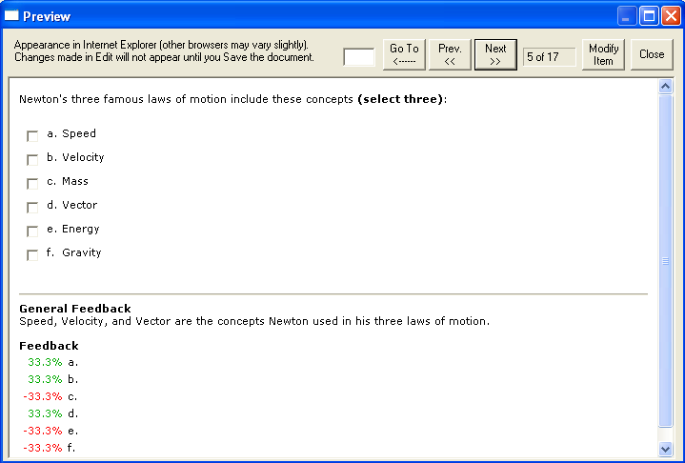

The preview window shows how the question wording and answer choices will appear to students when they take the exam. The feedback and correct answer for the question is additionally displayed at the bottom of the window.

To edit the question being displayed in the Preview window, click the [Modify Item] button. The screen will change to the Edit menu and the question will be displayed in the editor. Make the required changes and click [Save Changes].

Publish to WebCT
The Publish to WebCT wizard is available from the Preview & Publish menu and it guides a user through the steps of publishing a quiz to WebCT. You must already have a WebCT account and password in order to use this task. In addition, it is helpful to understand the basic approach used by WebCT to create an online quiz.

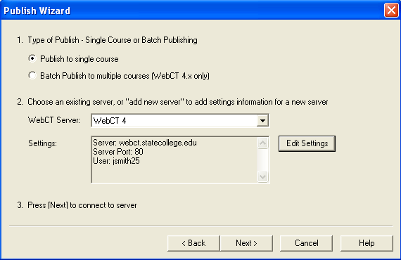

The initial decision is to choose if the quiz should be published to a single course or to multiple WebCT courses. (Note: This “Batch Publish” feature is only available in the Campus-wide version of Respondus.)

The second step requires that information be entered about the WebCT server and the user account. (This information can be stored for future use, enabling this step to be bypassed after the initial setup.) From the WebCT Server list, select “Add New Server.” A window will open.

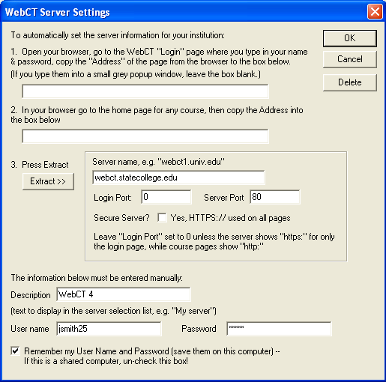

As instructed on the screen, open a web browser and go to the login page for the WebCT server. Be sure that you are at the actual page where the WebCT user name and password is entered, not a preliminary web page or portal. Copy the complete URL for this page and paste it in the field provided. (The easiest way to copy a URL displayed by a browser is to highlight it with a mouse, click the right mouse button, and select “copy.” Then go to the appropriate field in Respondus, click the right button again and select “paste.”)

Next, log into the WebCT course and go to the Home page. Copy the URL address for this page too and paste it to the appropriate field in Respondus. Upon clicking the “Extract” button, Respondus will fill in the Server Name, Login Port, and Server Port. The default “Server Port” is 80, but some institutions will use a different port number for their WebCT server. Respondus should detect the correct port numbers automatically during the extract step. But if it doesn’t, the Server port can be identified by looking at the course URL. For example, the port number for the following WebCT server is 8900: http://www.webct.statecollege.edu:8900. (If no port number is shown in the URL, the Server Port should be set to 80.)

If WebCT is installed on a "secure server" (https://), the secure server checkbox should be selected and the Login Port number should be set to 443. Some institutions use a secure login and then revert to non-secure pages elsewhere in WebCT. In these situations, the Login Port should be set to 443 and the Server Port should be set to 80. Again, Respondus can usually detect the correct settings when the “Extract” button is clicked.

Now provide a short description for the WebCT server. The server can be called anything you like, such as “My WebCT courses.” If more than one WebCT server will be accessed, you will want to select a name that helps differentiate the two servers.

Enter a designer-level User Name and Password. This information should be the same as what is entered when using a web browser to access your WebCT course. If you want Respondus to remember the User Name and Password for future sessions, select the “Remember my User Name...” setting. Click [OK] to close the WebCT Server Settings window.

Before clicking [Next], be sure you are connected to the Internet. If using a dial-up connection, go ahead and connect to the Internet now.

Click [Next] to continue. The Windows hour-glass will appear momentarily. If the connection is successful, the next page of the wizard will appear. If the connection is unsuccessful, an error message will indicate that Respondus was unable to connect to the server using the provided settings. If this occurs, troubleshoot it as follows:

- Make sure you are running a supported version of WebCT and have the correct “personality” selected from the Start menu in Respondus.

- Make sure your connection to the Internet is working properly.

- Double-check the designer-level Password and User ID information. In fact, open your browser, go to the WebCT server, and enter the identical login information. This will confirm that the WebCT server is running and that the User ID and Password are correct.

- Check that the port and secure server settings are correct.

- Make sure you are running the latest version of Respondus (go to Help>Check for Update to see if a more current version is available).

On the next page of the wizard, select a course from the pull-down list.

WebCT requires that questions be placed in a “category” (i.e. a question database) before they are used in a quiz or survey. So decide whether to create a new WebCT category or use an existing one. To use an existing category, select the second option and choose a category from the pull-down list. All questions will be appended to this category.

The remaining selections are optional including the creation of a quiz (it is possible to publish a “category” to WebCT without a quiz).

To create a quiz or update an existing one, select the “Create or Update Quiz” option. If creating a new quiz, enter a name for the quiz or use the default name provided. To update an existing quiz, select a quiz from the pull-down list. If an existing quiz is selected, a popup window will ask whether to erase the original questions or to append the questions in the current file to the original quiz file. Make your selection and click [OK].
Other options can be selected at this point. If Question Sets were created for the quiz (see the Settings menu) they will be uploaded if the Question Sets option is selected. The point values and selections from the Settings menu can also be uploaded with the quiz.

Click [Next] and Respondus will begin publishing the quiz and settings to the WebCT course. A status report appears during the publishing process. For a typical quiz, the publishing process takes 20-40 seconds. This can increase to five minutes or more if a large number of media files are being uploaded or if the server connection is particularly slow. You will know that the publish process is complete when the hourglass disappears and the phrase “Completed successfully” appears in the “status” window.

After an exam is published to WebCT, it is recommended that you go to the course and confirm that everything appears as expected.

Add WebCT Self-Test
Respondus makes it possible to use an exam file to create a WebCT self-test. From the Preview & Publish menu select Add WebCT Self-Test. Select the WebCT Server and then select the Course. After the course information is returned from the server, select the specific page to be used for adding the self-test. WebCT permits self-test to be added to an “organizer page,” but you will generally want to add it to a page in the “content module.” You are not permitted to add a self-test to a content module itself, and Respondus will prevent you from trying to do so.

If the content module to which you want to add a self-test does not yet have a sub-page (a necessity for adding a self-test), you will need to go to your WebCT course with a browser to add a page.

Once the server, course, and destination for the self-test is selected, click the [Publish] button. The publishing process will take from 15 seconds to several minutes, depending on several factors: the speed of the connection, the load on the server, the size of the media elements that are being uploaded, and so forth. Toward the end of the publishing process, you will be asked “Do you want Respondus to update the student view?” By selecting “yes,” the student view will be updated in the WebCT course. (If you answer “no” to this prompt, it will later be necessary to update the student view in WebCT so that students can view the self-test.) The publish process is complete when the phrase “Complete Successfully” appears in the status window.

Important: If your Respondus file contains question types other than multiple choice and true/false, these questions will be bypassed when the self-test is uploaded. WebCT’s self-test tool only supports multiple choice (and true/false) questions.

Update Settings
Respondus can be used to update the settings for a quiz that already exists in WebCT. From the Preview & Publish menu, select the Update Settings tab. Follow the sequence for selecting the server, the course, and the quiz. Click the [Settings] button to obtain the current settings for the selected assessment. Make the desired changes to the settings and click the [Publish New Settings] button. The status bar will indicate when the new settings have been successfully published to the course.

Printing Options
Respondus allows you to format and print exams/surveys directly from the software. It is also possible to save an exam to MS Word format for further enhancement and printing. To begin, go to the Preview and Publish menu in Respondus and select the Print Options tab.

The screen now displays the printing options available in Respondus. There are three formatting templates from which to select: Exam, Exam with Answer Key, Answer Key Only. Once a template is selected, you can further modify it by clicking the Settings button to its right. If the exam being printed has matching questions, be sure to select the checkbox labeled "Matching, randomize answers" if you want the second set of answers to be randomized. Also, if you have sequential questions that refer to the same image or graphic, you will likely want to select the “Suppress Repeated Images” button so that the image is not repeated with each question.

Click the [Edit Headers] button to enter the information you want to appear at the top of each page. Different information can be entered for the second and subsequent pages too. The header information might look something as follows:
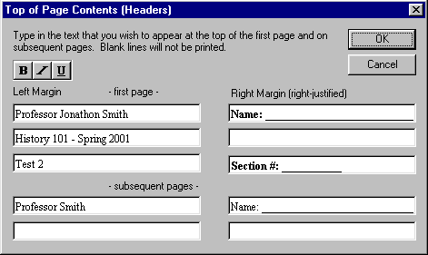

The next section allows up to 10 variations of the exam to be generated. You have the ability to “randomize all” questions in the exam or to have the questions randomized according to question type (i.e., all the multiple choice questions are randomized within a group, all the essay questions are randomized within a second group, and so forth). If Calculated questions are contained in the file, each Exam Variation will have a unique set of variables for the calculated questions. If you don’t want multiple exam variations, simply retain the “Original Order” option from the pull-down list. (Note: As long as the questions in the exam file remain unchanged, a particular “Exam Variation” will have the same question order each time it is printed or saved to MS Word format. However, if you add or insert new questions, the Exam Variation will differ the next time you print/save an exam or answer key.)

It is also possible to specify a range of questions to be included in the exam. If both fields are left blank, all questions will be included.

At the bottom of the screen there are three options: Print Preview, Save to File, and Send to Printer. The Print Preview button allows you to preview the contents of the file in a pop-up window. We recommend that you use this option before printing the exam/survey or saving the contents to a file--it is a quick way to identify mistakes. The Save to File option allows the creation of a MS Word file (.doc), a “rich text file” (.rtf), or a standard text file (.txt). The MS Word and .rtf formats will retain enhanced formatting such as bold, italics, and underlining, whereas the .txt format will strip such information. Once a file is saved, it can be opened with a word processor for further formatting and modification. Finally, the Send to Printer option permits you to print directly from Respondus. This task works similar to the printing function in other Windows programs.

Retrieval and Reports
Overview
Retrieving Reports for Quizzes/Surveys
Downloading Data from Quizzes/Surveys
Retrieving a Quiz or Category from WebCT

Overview
Once a quiz or survey is administered in WebCT, Respondus allows you to retrieve reports that contain such things as student scores, the grading status, summary statistics, and answer distributions. You can also download the database that contains the answers provided by students. The final option on the Retrieval and Reports menu allows the retrieval of the quiz/survey instrument from WebCT so that it can be modified in Respondus, published to another course, or archived.

Retrieving Reports for Quizzes/Surveys
WebCT can generate a variety of reports for quizzes and surveys. Respondus enhances these capabilities by retrieving reports from multiple locations in WebCT and consolidating them into a single page. Since these reports are automatically saved to the hard drive, it is possible to view results offline or to archive the reports at the conclusion of a course.

To retrieve a report using Respondus, go to the Retrieval and Reports menu and select the Retrieve Reports tab. The first several steps are similar to those used for publishing a quiz to WebCT (see the earlier discussion for a detailed explanation). First select the WebCT Server and the Course. Then select the quiz or survey for which you want the report.

Three different elements can be included in a report. The first checkbox will retrieve the student scores, grading status, and related information (for a survey it will simply list those who have and haven’t taken the survey). The following information will be displayed:

Sprague - Economics 410
Quiz 4
February 18, 2001 16:50
Students who completed the quiz
User ID | Name | Grade | Attempts
DAikers | Don Aikers | 60.0 | 2
FBaker | Felicia Baker | 80.0 | 1
BBooth | Brian Booth | 70.0 | 1
LBrady | Lisa Brady | 70.0 | 3 (1 ungraded)

Students requiring items to be graded
User ID | Name
LBrady | Lisa Brady

Open WebCT “Submissions” page

Students registered for course who did NOT attempt the quiz
User ID | Name
WArgos | William Argos
ACorbet | Alexia Corbet

The second checkbox allows you to retrieve summary statistics for each quiz question (this option is dimmed if you are obtaining reports for a survey). The table is identical to the one you can obtain in WebCT by selecting the “Summary” option.

Summary Statistics
Title | N | %Correct Of: |  |  | Discri-  mination | Score
Title | N | Whole Group | Upper 25% | Lower 25% | Discri-  mination | Mean | SD
Intervening Variables | 11 | 72 | 100 | 0 | 0.91 | 72.7% | 46.7
Cross-case comparability | 11 | 45 | 100 | 0 | 0.60 | 45.5% | 52.2
Creating an index | 11 | 63 | 100 | 0 | 0.80 | 63.6% | 50.5
Antecedent variables | 11 | 100 | 100 | 100 | 0.00 | 100.0% | 0.0
 |  |  |  |  | Overall Mean | 70.5%

The third and final checkbox allows you to retrieve answer distributions for each question. Be forewarned that it can take a long time to generate this part of the report--anywhere from 20 seconds for a short quiz to 30 minutes for a quiz with over 150 questions. However, if these statistics are of interest to you, it will be considerably faster to obtain this information using Respondus than to manually generate a comparable report for each question within WebCT. The report will contain the following information for each question:

Question: Intervening Variables

Answer Value Frequency Distribution
1 0% 3 +++++++++++
2 0% 0
3 0% 3 +++++++++++
4 100% 5 ++++++++++++++++++++

All reports are formatted in HTML. Your web browser will automatically open and display the report once it is generated. The report is also saved to your hard drive and can generally be found in the following folder: c:\Respondus Projects\Reports.

Downloading Data from Quizzes/Surveys
Respondus will download answer databases for quizzes or surveys. The results are saved as “comma separated values” files (.csv) which are easily opened by Excel, Access and many statistical analysis programs. The download feature in Respondus is especially useful with surveys since additional analyses (e.g., crosstabs) are usually desired.

To download an answer database, go to the Retrieval and Reports menu in Respondus and select the Download Data tab. The first several steps are similar to those used for publishing a quiz to WebCT (see the earlier discussion for a detailed explanation). First select the WebCT Server and the Course. Then select the quiz or survey for which you want to download the answer database.

You are now prompted to provide a name for the database that will be downloaded (the file extension “.csv” will automatically be added to the file name). If you want to download the file to a folder other than “c:\My Documents” use the [Browse] button to identify the folder and to enter the name of the file. Click the [Retrieve] button to begin the download process. Be forewarned that the download process can take anywhere from 30 seconds to 30 minutes, depending on number of questions in the quiz/survey, the number of students or respondents, and the speed with which the server can communicate with Respondus. Once the file is downloaded, you should be able to open it directly by selecting the [Open CSV File] button. If this doesn’t automatically launch a program capable of opening .csv files (e.g., Excel, Access), start the software you want to use to access this data file and open it from there.

It is important to note that a database retrieved by Respondus may not match a database that is downloaded using WebCT Server. That’s because Respondus maintains blank spaces for students or survey respondents who do not provide answers to questions, whereas WebCT 2.x and 3.x do not.

Retrieving a Quiz or Category from WebCT
Respondus allows the retrieval of quizzes, surveys, and “categories” from a WebCT course. To begin, go to the Retrieval and Reports menu in Respondus and select Retrieve Questions. The first couple of steps of retrieving a quiz/survey or category are identical to those used for publishing a quiz to WebCT (see the earlier discussion for a detailed explanation). First select the WebCT Server, then select the Course. Once the course information is obtained from the server, select the appropriate radio button for retrieving either a quiz/survey or a category. Then select the desired file you want to retrieve from the pull-down list. Finally, enter a name for the new file you are creating.

Once all selections have been made, click the [Retrieve] button. The retrieval process will take between 15 seconds and several minutes, depending on several factors: the speed of your connection, the load on the server, the size of the media elements that are being retrieved, and so forth. You will know that the retrieval is successful by the statement “Successfully completed” that appears in the status box.

When a file is being retrieved, Respondus will detect if media objects are associated with it and will automatically download these objects if they are stored with your WebCT course. (Respondus does NOT attempt to download media elements if they are stored on a different server.) If media objects are retrieved with a file, Respondus will automatically update the HTML links in questions that point to these objects. This makes the media elements work properly when the file is published again to WebCT.

If you created and uploaded image-based equations to WebCT using Respondus, when these questions are retrieved from WebCT the equations will be handled as images, not equations. This means that if you want to use Respondus to modify an equation that was retrieved from WebCT, you will first need to delete the equation graphic using the “Insert Picture or File” option (see related discussion) and then use the Equation Editor to create the new equation. Hence, it is usually better to start with your original Respondus file since it permits you to edit the equation directly. Also, if you are providing a colleague a quiz that contains equations, it is best to send that file in the original Respondus format so the person can edit the equations more easily.

If a WebCT quiz contains question sets, Respondus will maintain these sets during the download.

Other Tools & Features
Overview
Save As Copy
Save As StudyMate Class Format
Preferences
Question Title Tool
Check for Update

Overview
There are several additional tools in Respondus that offer a range of functions. Each of these is discussed below.

Save As Copy
The “Save As Copy” tool is located on the File pull-down menu. Use this task to create a copy of the currently open file.

Save As StudyMate Class Format
The Save As… tool, located on the File pull-down menu, can also be used to save Multiple Choice and True/False questions to the StudyMate Class zip format (.zip). Once saved, the file can be imported into a StudyMate Class instance or by StudyMate Author, a separate product by Respondus Inc.

Question types other than Multiple Choice and True/False are dropped during the export to the StudyMate Class zip format.

Exported items that contain images are handled as follows. If an item contains a single image, that image is placed at either the beginning or end of the question once it’s imported by StudyMate Class (the beginning/end positioning is based on its proximity to the beginning or end in the original question wording). If an item has multiple images, only the first image is retained, with the text “*IMAGE*” inserted where additional images appeared in the original item.

The StudyMate Class format can also be imported into StudyMate Author, with True/False questions being converted to Multiple Choice questions with only two answers.

Preferences
A “preferences” option, which is located on the File menu bar, contains three tabs: General, Edit & Publish, and Conversions.

The top section of the General preferences allows you to prevent Respondus from automatically checking for updates to the Respondus software. (The checking occurs whenever an exam is published from Respondus to an online course.) Directly beneath this is a list of course management systems. If you only want to be informed of updates that relate to specific course management systems, unselect those systems for which you are not interested. The final option on the General tab allows the current description of the Respondus file to be edited.

The Edit and Publish preferences provide a variety of options:

- The ability to discard font changes when copying and pasting from another program
- The ability to change the default point value for new questions that are created or imported
- The ability to prevent the “ALT text” window (for entering text for screen readers) from appearing each time an image is added to an exam
- The scaling percentage that should be used for equations that are published to WebCT
- The ability to have the “randomize answers” checkbox selected when a new question is created on the Edit menu.
- The ability to change the default font for questions that are published to WebCT. (We highly recommend that you don’t change the default font. If you change the default font and later need to edit your questions from within WebCT using a browser, it will be more difficult because the font HTML will be intermixed with the question wording. Also note that changes to the default font will not be applied to tables or any text that already has a specific font applied it.)
- Changing the “randomize” setting for multiple choice and multiple response questions in Edit.

The bottom section of the Edit and Publish tab lets you specify the format that equations will be published to WebCT. This is discussed in detail above in the “Equation Editor” section.

The third preference tab, Conversions, allows the settings to be determined for which a file is converted from one CMS personality to another. If you do not want to be asked each time how certain issues should be handled for the file conversion, then select the settings that you prefer.

Question Title Tool
There are many situations when it is desirable to rename all the titles in the Respondus file to provide a consistent look or numbering sequence. For example, if you copy questions from many different files, import additional questions to that file, and then create some questions directly within Respondus, you may end up with a haphazard list of titles.

The Question Title Tool, located under File on the menu bar, lets you specify a “stem” (or string of text) that all question titles will start with. The stem text will then be followed by consecutive numbering that begins with 1 (or 01, or 001, etc.). For example, if you enter “Chapter1-” as the stem text, and then select “001” as the format for the numbering scheme, the title for the first question will be changed to Chapter1-001, the title for the second question will be changed to Chapter1-002, and so on. If you specify a range of questions for the titles being changed, you can provide even more specific titles throughout your file. For instance, questions 1-20 might use the stem “Ch1-Unit1-” and questions 21-30 might use the stem “Ch1-Unit2-” and so forth.

Check for Update
The “Check for Update” tool, located on the Help pull-down menu, provides an easy way to see if an update is available for Respondus. When Respondus is used to publish an exam, it will automatically check to see if an update is available for the Respondus software (this check will occur only once in a 24-hour period). No information about your computer hardware and software is collected by Respondus, Inc. during this process. Instead, the Respondus software retrieves information from Respondus.com and will display a message if an update is available. You will then have the choice of upgrading to the latest version of software.

To manually check for a software update, select the “Check for Update” option from the Help pull-down menu (you will need a live Internet connection). Respondus will instantly return a message indicating whether an upgrade is available. If an upgrade to Respondus is available, you can let Respondus download the required file(s) automatically and update the software for you. This is the easiest way to apply a patch or upgrade.

If you prefer that Respondus does not automatically check for an update during the publishing step, go to the File menu, select Preferences, and unselect the appropriate checkbox under the General tab.

Disclaimer of Warranty
While Respondus, Inc. has tried to ensure the dependability of the software and documentation, it is provided "as is" without warranty of any kind. Agents of the supplier may have made statements about this software. Any such statements do not constitute warranties and shall not be relied on by individuals in deciding to use the program.

Because of the diversity of conditions and hardware under which this program may be used, no warranty of fitness for a particular purpose is offered. Test the program thoroughly before relying on it. You assume the entire risk of using the program. Respondus, Inc. shall not be liable for any expense, claim, liability, loss, or damage (including any incidental or consequential damage), loss of profits, loss of reputation, or any loss whatever direct or indirect, by you from either the use of or the inability to use the software.

Copyright, Ownership, and Use of Software
All software, with exception of Equation Editor by Design Science and the Sentry Spelling-Checker Engine by Wintertree Software, remains the property of Respondus, Inc. The software and written materials are copyrighted. This license is not a sale of the original software or any copy. You own the physical media on which the software is originally or subsequently encoded, but Respondus Inc. retains title and ownership of the software on all media.

You are not permitted to install the executable code version of this product on a network server or virtual server. You may not customize the Respondus “Product.” Except as otherwise permitted by written consent, you may not: (i) modify or create any derivative works of the Product or documentation, including translation or localization; (ii) decompile, disassemble, reverse engineer, or otherwise attempt to derive the source code for the Product; (iii) redistribute, encumber, sell, rent, lease, sublicense, or otherwise transfer rights to the Product; or, (iv) remove or alter any trademark, logo, copyright or other proprietary notices, legends, symbols or labels in the Product.

© 2000-2010 by Respondus, Inc. All Rights reserved. The Equation Editor and documentation are copyrighted by Design Science, Inc. The Sentry Spelling-Checker Engine is copyrighted by Wintertree Software, Inc.

Respondus is a registered trademark and Respondus LockDown Browser is a trademark
of Respondus, Inc. All other trademarks are the property of their respective owners.
Copyright © 2010 Respondus

